E-ksena: An AI-Powered Emergency Detection and Dispatch System Using Short-Form Video Analysis for Real-Time First Responder Allocation"

Project Documentation Submitted to the Faculty of the
School of Computing and Information Technologies

Asia Pacific College

In Partial Fulfillment of the Requirements for
Introduction to Systems and Design for IT
SNTSDEV

By
Peter Arquines Jr. | Lance Benedict Onnagan
Jesmark David Presbitero | Paul Brian Sumilhig

Table of Contents
Introduction 1
Project Context 1
Statement of the Problem 2
Objectives 2
Significance of the Project 3
Scope and Limitations 4
A. Scope 4
B. Limitations 5
Review of Related Literature / Systems 6
SWOT Analysis 8
PM Docs Chapter 2 8
Charter 8
Objectives 11
Scope 12
Stakeholder Analysis 14
Requirements Analysis 14
Project Vision 14
Design Thinking 15
Stage 1: Empathize 15
Actual Personas 26
Empathy Maps 29
Stage 2: Define 30
Stage 3- Ideate 33
Brainstorming Session 33
Stage 4: Prototype 40
4.1 Story Boards 40
4.2 Wireframe 43
Stage 5: Testing 51
Technology Stacks 52
Dataflow Diagrams 54
Use case Documentation 60
Use Case Diagram 60
Use Case Full Description 60
Activity diagrams with swim-lanes 77
Test Cases 92
Conclusion 96
References 98
Appendices 99

List Of Figures
Figure 1: Patrolman Cenon E. Mariano III 29
Figure 2: CFRS. Mark John B. Manalansan 29
Figure 3: Dr. Daniel T. Roldan 30
Figure 4. Paul Brian Sumilhig (Team Leader) 34
Figure 5. Jesmark Unit Tester Front end 35
Figure 6. Peter Backend / Security 36
Figure 7. Lance Cloud Engineer/Front-end 36
Figure 8. Post it Voting 38
Figure 9. Desirable, Viable, Feasible 39
Figure 10. Citizen Log in 40
Figure 11. Citizen Report 41
Figure 12. User Communication 41
Figure 13. User Dispatcher Log in 42
Figure 14. Dispatcher Responds 42
Figure 15. Report Stats 43
Figure 16. Login Page 44
Figure 17. Registration Page 45
Figure 18. Home page 46
Figure 19. Recording of Incident 47
Figure 20. Sending Video 48
Figure 21. Website Log in 49
Figure 22. Website Dashboard 49
Figure 23. Website Response Tab 50
Figure 24. Website Response Tab 50
Figure 25. Website Response Tab 51
Figure 26. Website Incident Date Tab 51
Figure 27. Dataflow Diagram Level 0 54
Figure 28. Dataflow Diagram Level 1 55
Figure 29. Dataflow Diagram Level 2.1 56
Figure 30. Dataflow Diagram Level 2.2 57
Figure 31. Dataflow Diagram Level 2.3 58
Figure 32. Dataflow Diagram Level 2.5 59
Figure 33. Dataflow Diagram Level 2.5 59
Figure 34: Use Case Diagram 60
Figure 35. UC-01 77
Figure 36. UC-02 78
Figure 37. UC-03 79
Figure 38. UC-04 80
Figure 39. UC-05 81
Figure 40. UC-06 82
Figure 41. UC-07 83
Figure 42. UC-08 84
Figure 43. UC-09 85
Figure 44. UC-10 86
Figure 45. UC-11 87
Figure 46. UC-12 88
Figure 47. UC-13 89
Figure 48. UC-14 90
Figure 49. UC-15 91
Figure 50. Entity Relationship Diagram 115

List Of Tables
Table 6. Use Case: User Register 60
Table 7. Use Case: Responder Register 62
Table 8. Use Case: User Log In 63
Table 9. Use Case: Responder Log In 64
Table 10. Use Case: User Change Password 65
Table 11. Use Case: Responder Change Password 66
Table 12. Use Case: User Log Out 67
Table 13. Use Case: Responder Log Out 68
Table 14. Use Case: Send Incident Video 69
Table 15. Use Case: Send Dispatch Details (Assignment) 70
Table 16. Use Case: Call Responder 71
Table 17. Use Case: Respond to User 72
Table 18. Use Case: Contact Responder via SMS 73
Table 19. Use Case: Monitor Location 75
Table 20. Use Case: View Dispatch Details 76
Table 20. Test Cases 92
Table 21. Roles and Responsibilities 99
Table 22. Requirements Traceability Matrix 109

Introduction
E-ksena is a mobile-to-web application with a system that uses artificial intelligence to automatically determine a video message and its emergency types including fires, violence, medical events, and accidents, then directs these reports to the nearest and most appropriate first responder. The application uses GPS technology and an alarm system to provide responders with enhanced tracking plus notifications during an emergency.

Project Context
The product’s vision is to create a streamlined process using technology to eliminate barriers and inefficiencies of traditional emergency hotlines. The application's mission centers on providing citizens with a one-button video capture solution that simplifies emergency reporting while ensuring that first responders receive accurate, real-time information with visual evidence to facilitate rapid and appropriate responses.
The main users for E-ksena are average citizens who need quick and effective emergency reporting capabilities, emergency response personnel working at barangay halls, hospitals, and fire stations, or local government units responsible for emergency management. The demand for this is evident in the Philippines' current emergency response challenges. The existing emergency response system suffers from inefficiencies due to manual processes and outdated communication methods. An example is:
[1] Citizens calling for emergency assistance often experience delayed responses from facilities, with the Emergency Medical Services system averaging response times of 15 to 30 minutes, which falls well below the international standard of 8 minutes.
[2] Data from police officers responding to 1,137 calls posted an average response time of 12.86 minutes. This demonstrates the current system's inefficiency and highlights the need to change traditional systems.
E-KSENA contributes to SDG 3 (Good Health and Well-being) by enhancing emergency response time and accuracy, ultimately saving lives. It also supports SDG 11 (Sustainable Cities and Communities) by improving the safety and resilience of urban and rural areas through smart public safety innovation.
The platform aligns with the National ICT Agenda for Sustainable Development (NIASD) through its use of digital tools to promote responsive government services, inclusivity, and disaster risk reduction. It embodies the NIASD vision of harnessing ICT for safer, more efficient communities by modernizing emergency response systems using AI, mobile technology, and geospatial intelligence.

Statement of the Problem
This study explores the effectiveness of an AI-powered emergency video reporting tool (E-ksena) in facilitating assistance requests, increasing contact with responders, and addressing systemic issues to improve intelligence and expedite emergency responses.

This study will specifically investigate the following:

- What challenges do people face when making a report using current hotlines and systems?
- How can AI technology serve to sort out true emergencies from bogus prank calls, and prioritize equipment, and responders to the topic at hand?
- What key features and tools need to be included in a video-based emergency reporting app to make it easy to report emergencies reliably?
- What relevance will location trigger have to ensure responders are faster and more accurate in their response?
- How can a community emergency reporting app (e-ksena) facilitate better response time and ability to helpful help in emergencies?

Objectives
The primary objective of this project is to develop a mobile-to-web emergency reporting system, E-ksena, that leverages artificial intelligence and real-time video to improve the speed, accuracy, and efficiency of emergency response in the Philippines.
To achieve this, the project has the following specific objectives:
- Identify and address key challenges in the current emergency hotline systems, such as slow response times, inefficient communication, and lack of visual context, by integrating real-time video reporting and automated emergency classification.
- Implement artificial intelligence that can differentiate real emergencies from false or prank reports, ensuring prioritization of valid incidents and proper allocation of responders and equipment.
- Design an intuitive mobile application interface that enables citizens to easily and reliably report emergencies using a single-button video capture function.
- Integrate GPS-based location triggering that automatically shares the user’s coordinates with responders, enabling faster and more accurate deployment of help.
- Evaluate the effectiveness of the E-ksena platform in reducing response time and improving emergency handling by conducting pilot testing with real users and emergency response teams.

Significance of the Project
This study presents the development of an intelligent emergency response platform that leverages real-time video reporting and AI-driven emergency classification to enhance public safety and improve the responsiveness of first responders. The proposed system is designed to streamline emergency communications, ensuring rapid and accurate dispatch of help during critical situations.
The significance of this study is multifold:
- For Future Students:
This study serves as a comprehensive case on how emerging technologies—particularly AI and real-time media processing—can be applied to solve critical real-world problems. It offers valuable insights into interdisciplinary project development, combining elements of computer science, public safety, and user experience design. Students can use this study as a reference or foundation for academic projects, theses, or capstone initiatives related to smart technologies and emergency response systems.
- For Future Developers:
Developers can benefit from the system architecture and methodologies used in building e-Ksena, particularly in real-time video processing, geolocation-based services, and API integrations with emergency dispatch systems. The study demonstrates how to create scalable, secure, and user-friendly web applications capable of life-saving functionality, providing a valuable reference for those developing next-generation civic tech solutions.
- For Emergency Response Institutions and Local Government Units (LGUs):
The study proposes a scalable framework that can be adopted by LGUs, hospitals, and emergency response teams to enhance their response capabilities. The platform fosters public-private collaboration by integrating with 15–20 partners for pilot testing, highlighting how technological innovations can modernize traditional emergency protocols. It also enables more efficient resource allocation and faster response times.
- For Entrepreneurs and Tech Startups:
By exploring subscription-based monetization models targeted at institutions such as schools and municipalities, the project introduces a sustainable business approach to civic technology. It demonstrates how socially impactful innovations can also be economically viable, encouraging startups to pursue similar ventures that balance profit with the public good.
- For the General Public and End-Users:
The study prioritizes intuitive design and system reliability to ensure an 80%+ user satisfaction rate. By improving citizen experience and trust in digital emergency systems, e-Ksena empowers users to actively participate in their own safety and community resilience. It promotes the normalization of using smart tools during emergencies, ultimately fostering a more responsive and connected society.
- For Future Researchers:
The integration of AI for intelligent incident classification contributes to the growing body of research in applied machine learning and computer vision. By aiming for over 95% classification accuracy, this project sets a benchmark for future studies exploring high-risk, time-sensitive applications of AI. It also opens further research opportunities in improving algorithmic fairness, bias mitigation, and real-time data processing in critical settings.
In summary, this study is significant not only for its technological innovation but also for its potential to influence educational curricula, advance academic research, support modern software development, strengthen emergency response infrastructure, and contribute to a safer and smarter society.

Scope and Limitations

A. Scope
This study focuses on the development and deployment of a smart emergency response system that integrates both mobile and web-based platforms. The primary features included in the scope are:
- Resident Registration and User Authentication. Enables users (citizens) to register and securely log into the system to access emergency services.
- Emergency Reporting via Multimedia Input. Allows users to report incidents through video and audio inputs to capture real-time emergency situations.
- AI-Based Emergency Classification. Utilizes artificial intelligence to analyze multimedia reports, automatically classifying the nature of the emergency and routing the report to the most suitable first responder unit.
- Automatic Geolocation Sharing. Incorporates GPS-based location detection to provide responders with the exact location of the emergency without requiring manual input from the user.
- Information Dissemination. Supports the publication of relevant news, alerts, and announcements via a web-based platform accessible to Local Government Units (LGUs) and associated personnel.
- Responder Web Interface. Offers a dedicated web application for first responders, including barangays, hospitals, and fire stations, to receive, view, and manage emergency data efficiently.
- Alarm and Notification System. Provides an internal alarm and tracking system to improve the response time and coordination of emergency personnel.
- Path Navigation: Integrates a navigation feature to guide responders to the exact location of the reported emergency.
- Ticket Management System. Implements a structured interface for responders to track, update, and manage emergency reports systematically.

B. Limitations
While the proposed system aims to enhance emergency response through advanced technologies, it has several limitations:
- Dependence on Internet Connectivity. Both mobile and web applications require stable internet access for optimal performance, which may not be available in remote or disaster-affected areas.
- AI Accuracy and Bias. The effectiveness of the AI emergency classification depends on the quality and diversity of the training data. Misclassification may occur in ambiguous or unclear multimedia inputs.
- Hardware Limitations. Users must have devices capable of recording and transmitting audio/video, which may exclude individuals with older or non-functional smartphones.
- Privacy and Data Security: Despite implementing secure login and encrypted location sharing, there is a risk of data breaches that may expose sensitive personal or location data.
- System Scalability. The initial version of the system may not handle high volumes of simultaneous reports effectively without additional infrastructure.
- User Error. Incorrect or incomplete submissions from users may lead to delays or mismanagement of emergency responses.

Review of Related Literature / Systems
In today’s fast-paced and risk-prone environment, rapid emergency response is critical in saving lives and minimizing damage. The integration of artificial intelligence (AI) into emergency systems introduces an innovative approach to incident detection and dispatch optimization. The recent upgrade of the Philippine 911 emergency system, which now features next-generation capabilities, exemplifies the nation’s move toward technologically enhanced response mechanisms [1]. As reported by the Philippine National Police, 78% of emergency calls are now responded to within five minutes, demonstrating significant improvements in emergency service delivery [2]. Complementing this progress is the development of AI-powered mobile applications that analyze short, 5–10 second videos submitted by users to identify the nature of an emergency—whether medical, criminal, or fire-related—and automatically relay the incident to the nearest and most appropriate first responders. This aligns with optimization-based models that improve ambulance performance [3], as well as studies on response time dynamics in urban settings [4]. These technologies contribute to a more intelligent, efficient, and life-saving emergency response framework.

Ai in Emergency Response
AI plays a vital role in classifying emergency types, filtering non-urgent cases, and reducing prank calls that burden hotlines globally. A study in Brazil showed how AI transcription and categorization improved the identification of care-sensitive conditions [5]. Similarly, systems like EmergEye apply AI to video feeds for enhanced situational awareness and real-time coordination [6]. AI-driven audio and text analysis also shows promise. Machine learning algorithms can accurately detect emergency vehicle sounds to improve traffic response [7], while large language models are being tested to help telecommunicators classify and prioritize crisis messages during major events [8]. Although difficult to quantify, pranks and non-emergency calls remain a persistent issue. AI tools using voice stress analysis, pattern recognition, and caller profiling are being developed to flag false calls. E-ksena’s AI-powered classification system offers a localized solution by verifying user-submitted emergency videos, ensuring only genuine reports reach responders.

Location-Based Services and Safety Applications
Location-Based Services (LBS) are prevalent in our daily lives. [9] These are mostly used in travel, social networking, tracking, and emergency services for issues like medical incidents. The product of this paper, E-ksena will use Global Positioning System (GPS) technology for accurate user tracking. Similarly, Google Maps relies on GPS data collected from millions of devices globally to provide accurate navigation [10]. Life360 is a popular location-sharing application that enables family members, friends, or loved ones to share their location information with one another [11]. In addition, Life360 offers features notifications for arrivals or departures from designated locations, and it includes a crash detection feature but to automatically call for emergency services it requires a premium subscription level. Comparing Life360 and Google Maps, both have great tracking capabilities, and it also diverges in their specific feature sets. [10],[11] Life360 main features are notifications of a user's location to their trusted circle and provides instant access to emergency services at premium levels if needed, while Google Maps focuses on a broader navigational ability and its capability to interact with establishments and offering extensive information about businesses and points of interest. E-ksena includes features similar to these applications and to mention E-ksena's unique feature is an AI detection tool that analyzes incoming video messages to identify urgent situations like intense fires, visible medical emergencies, and violent acts, ensuring emergency alerts reach the right professionals.

Synthesis
The integration of artificial intelligence (AI), geolocation, and real-time communication tools in emergency response systems represents a pivotal advancement in modern public safety infrastructure. Various studies and systems have demonstrated how these technologies significantly improve emergency detection, classification, and dispatch efficiency. The Philippine 911 emergency system's next-generation upgrade, which now responds to 78% of calls within five minutes [1][2], exemplifies the critical impact of technological modernization on response time. These improvements are complemented by AI-based solutions like EmergEye, which uses video analysis to identify car accidents in real time, showing the potential of visual input in enhancing situational awareness and coordination [6]. Similarly, AI-driven classification tools have been explored in projects such as the Brazilian AI transcription system, which improved the identification of care-sensitive conditions by analyzing emergency call data [5]. This reinforces the value of intelligent filtering, particularly in reducing the burden of prank calls and non-urgent reports—an issue that E-ksena also addresses through its video verification mechanism. Moreover, location-based services (LBS), such as those used in Google Maps and Life360, showcase how GPS tracking can aid in accurate user positioning and timely dispatch. While Life360 offers notifications and crash detection for emergency scenarios, it requires premium subscriptions for full functionality [10][11]. E-ksena builds on these concepts by embedding automatic geolocation sharing and real-time responder navigation as core features of its emergency response system. The use of AI in emergency detection has further expanded to include audio analysis, such as detecting sirens or distress signals [7], and language model-driven classification, which aids telecommunicators in prioritizing messages during crises [8]. These developments highlight a shift toward multi-modal emergency identification systems that use video, audio, and textual cues—an approach E-ksena reflects through its AI-powered multimedia input analysis. Collectively, these studies and systems underscore the feasibility and necessity of E-ksena’s design. By combining AI-based classification, GPS tracking, and automated notifications within a unified platform, E-ksena not only mirrors global best practices but also introduces localized innovations tailored to the Philippine emergency landscape.

SWOT Analysis

Table 1. SWOT Analysis
STRENGHTS | WEAKNESSES
Inclusivity and Accessibility  Geolocation and Mapping  One-Button Emergency Reporting  AI-Powered Real-Time Response | Limited Testing Scope Initially  Technical Complexity  Risk of AI Misclassification  High Dependency on Network Infrastructure
OPPORTUNITIES | THREATS
Alignment with SDGs and NIASD  Nationwide Scaling  Data Analytics for Predictive Safety  Nationwide Scaling  Partnerships with LGUs and Telcos | Competing Solutions or Government Systems  User Adoption Barriers  False or Malicious Reports  Legal and Regulatory Risks

PM Docs Chapter 2

Charter
Purpose
The emergency app project was created to transform ordinary citizens into active first informants. Many emergencies—like medical situations, fires, or accidents—go unreported or are delayed due to a lack of fast communication. This app empowers bystanders or victims to quickly send verified incident reports using their phones. Our goal is to build a system that bridges the gap between citizens and responders, making emergency responses faster, more informed, and more coordinated through mobile technology.
High-level project description
SEAT is a mobile application for both Android and iOS users. It’s designed to improve the daily commuting experience. The app will have important features like:
- Real-time train arrival and departure times
- Crowd tracking so users can know how full a train is
- Alerts that notify users when they are 2–3 stations away from their stop
- A feature to top-up or reload their transit card using local e-wallets
- A QR code generator that can be used as a ticket for entering stations
Aside from the app, we are also building a simple admin dashboard where the admin (like train operators or our group for now) can manage announcements, check feedback, and monitor how users interact with the app.
We will go through different phases: planning, designing the interface, building the app, testing it with real users, and finally presenting it during our final defense.

Table 2. High-level milestone schedule
Milestone | Estimated Week
Finalization of UI/UX wireframes and user flow | Week 6
Development of core features (Platform, Cloud Systems, Ais, Google Maps Integration) begins | Week 7 - 9
Admin dashboard setup and system integration | Week 12
Internal testing (team only) | Week 10 (3 Days)
Usability testing with at least 50 users | Week 10 - 11
Gathering feedback and making revisions
Final testing and polishing | Week 12 - 13
Project presentation and final defense preparation | Week 14

Rough cost estimate and budget
We estimate a total budget of ₱5,000 to ₱8,000 to support the development and testing of the emergency reporting application. This estimate includes:
- Mobile data and internet usage for app development, team coordination, and live testing in the field
- Cloud server hosting and database services to support real-time incident reporting and communication
- SMS and notification service costs (e.g., Twilio, Globe Labs) for sending critical alerts and confirmations
- Google Maps SDK/API usage, depending on usage tier and map load demands
- Presentation and demo materials for showcasing the application
- Optional software tools, including UI/UX design platforms, testing tools, or WebRTC for call functionality
- We plan to leverage free and open-source technologies as much as possible. Any expenses will be split evenly among team members or sourced from minimal pooled funds.
Stakeholders
The success of the emergency app depends on several key stakeholders:
- Ordinary citizens and potential first informants – our primary users, empowered to report real-time incidents such as accidents, fires, or medical emergencies
- Emergency responders (e.g., barangay tanods, BFP, PNP, ambulance services) – who will receive, assess, and act on verified reports
- Local government units (LGUs) and disaster risk management offices – potential partners for integrating the system into official response protocols
- Healthcare responders – for cases where immediate medical attention is required from the scene
- Telecommunication providers – critical for enabling SMS and mobile-based notifications
- Our development team – responsible for the system’s architecture, implementation, and testing
- Academic mentors and evaluators – who guide the development process through the PBL framework
- Pilot testers and evaluators – who will validate system usability, accuracy, and reliability
Project manager
Paul Brian Sumilhig, Group Leader
Project manager’s responsibilities
- Make sure the group is on track with the timeline
- Assign tasks to each member and follow up on progress
- Communicate with the instructor when needed
- Assist in development, testing, and documentation
- Organize the presentation and final defense

Project manager’s authority
- Decide on which tasks should be done first
- Reassign tasks if someone can’t finish on time
- Handle the group’s budget and expenses
- Solve problems or misunderstandings in the group
- Make final decisions with team input
- Formal declaration of sponsor’s support

Sponsor Name: Jose Eugenio L. Quesada
Position: Project-Based Learning Instructor
Support Statement:
As the instructor for the Project-Based Learning course, I fully support the E-ksena emergency response app developed by the student group. This project demonstrates strong potential to transform ordinary citizens into active first informants, enhancing emergency reporting and response in the Philippines. It reflects the students’ ability to address real-world challenges through innovative and socially impactful technology. I encourage the group to complete the project with collaboration, dedication, and ingenuity.

Objectives
The team behind the E-ksena project aims to develop and implement an AI-powered emergency detection and dispatch system that uses short-form video analysis to allocate first responders in real time. Based on the inefficiencies and delays of traditional emergency hotlines have a negative effect on public safety and well-being.
The top priority is to improve emergency response time and accuracy. The team’s primary objective is to reduce the response time to 60 seconds or less from the time a video report is submitted to a responder being notified, and to achieve a classification accuracy of over 95%. This will help contribute to SDG 3 (Good Health and Well-being) and SDG 11 (Sustainable Cities and Communities).
The new system will also support a subscription-based business model targeting institutions like local government units (LGUs), schools, and municipalities. The technical requirements include developing a system that can run on both Android mobile platforms and a web platform for responders. The targeted date for the project’s official release is December 2025.

Table 3. Categorized Objectives

Objective | Category | Measure
Implement E-ksena a mobile-to-web emergency response system that reduces emergency response time to 60 seconds or less from video submission to responder notification | Performance | System implementation date and response time in seconds.
Achieve over 95% classification accuracy for emergency types (e.g., fires, violence, medical events) | Quality | AI model classification accuracy percentage
Develop and deploy a mobile application compatible with both Android and iOS platforms. | Technical | Mobile application compatibility across different platforms (Android, iOS).

Scope
Scope Statement
Project goal and objectives
To develop and implement E-ksena, a mobile-to-web emergency response system designed to significantly reduce emergency response time to 60 seconds or less from video submission to responder notification. The system will leverage AI video analysis, GPS tracking, and integrated mapping to ensure rapid, accurate, and coordinated emergency responses.
Project Boundaries
Within Scope
- Makati City mid-sized Emergency Response Units:
- Emergency Medical Services (EMS)
- Local Police Outposts and Stations
- Local Bureau of Fire Protection Departments
- Integration of mobile application with a centralized web platform for responders.
- Deployment of AI-based video analysis for classifying incident types.
- GPS, location tracking, and traffic-aware route suggestions.
Out of Scope:
- Wearable devices such as smartwatches, FitBits, and other non-smartphone devices.
- Coverage beyond Makati City during the initial deployment phase.
- Hardware procurement for emergency responders (e.g., radios, body cams).

Project Deliverables
- Web Platform for Emergency Response Units to receive, monitor, and manage incident reports.
- Mobile Application for citizens to report emergencies with video, location, and descriptions.
- AI-Powered Video Analysis for classifying emergency incidents in real-time.
- Location Services Integration using GPS and Google Maps for precise tracking and optimized routing.
- Alert and Notification System to instantly inform the nearest appropriate response unit.
- Database and Analytics Dashboard for monitoring incident statistics, classification accuracy, and response performance.
Success Criteria
- The web platform is actively used by all designated first responder units in the pilot area.
- The video analysis AI successfully determines the emergency and which unit to report to within 30-60 seconds.
- The average emergency response time is reduced to under 8 minutes within three months of deployment.
- The mobile application achieves a user adoption rate of at least 60% in the pilot area.
- Misclassified emergency reports are reduced by 75% compared to the baseline.
Project Assumptions
- LGUs will be cooperative and provide the necessary support for pilot deployment.
- First responders will have the required technical infrastructure to use the web platform.
- Citizens in the target area have access to smartphones with internet or mobile data.
- A sufficient dataset can be gathered to train the video analysis AI model.
Project Constraints
- Time: The project must be completed and ready for pilot deployment by the specified deadline (e.g., end of 2025).
- Budget: The project must adhere to a predefined budget.
- LGU cooperation: Delays in securing official agreements with LGUs could impact the project timeline.
- Locations: Initial deployment is limited to Makati City, and a broader rollout will be part of a future phase.

Stakeholder Analysis

Table 4. Stakeholder Analysis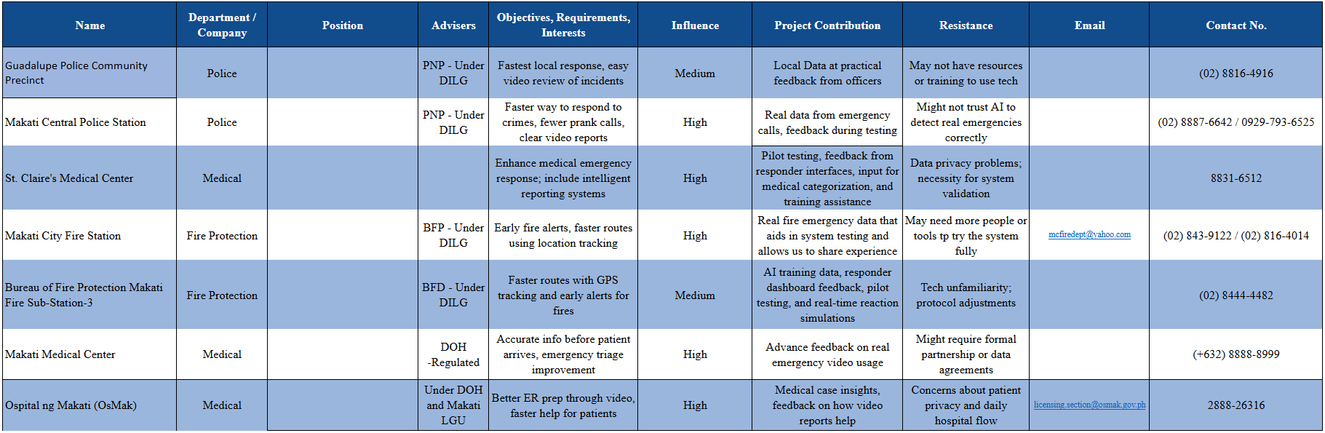

Requirements Analysis

Project Vision

Table 5. Project Vision
VISION | E-KSENA envisions transforming citizens into active first informants during emergencies through real-time video reporting. With AI-powered analysis and one-tap functionality, users can send accurate, visual alerts quickly.
TARGET GROUP | NEEDS | PRODUCT | BUSINESS GOALS
LGUs  Citizens  Emergency Responders | Quick and accessible way to report emergencies with context (visual evidence)  Real-time communication with emergency services, even with limited connectivity  Faster response times and accurate incident classification  A system that works even without load or fluent verbal communication | A mobile application enabling users to report emergencies via 5–10 second videos  An AI-powered web dashboard for emergency responders to receive and assess incidents  Features like geolocation tagging, offline SMS fallback, and real-time communication (WebRTC) | Reduce emergency response time by automating and streamlining the reporting process  Empower citizens to act immediately and effectively during emergencies  Improve coordination and efficiency of emergency responders through intelligent data  Scale the platform for national use and potential partnerships with telecoms and government agencies

Design Thinking

Stage 1: Empathize
Introduction
The first stage of the Design Thinking process is empathizing with the people we aim to serve. For E-ksena, this means going beyond assumptions and actively listening to the community. At this stage, our goal is to understand the real experiences, pain points, and aspirations of our target users — whether they are students, residents, or organizations who will engage with the platform. By putting ourselves in their shoes, we can uncover meaningful insights that will guide the design of solutions that truly address their needs.

Customer Interview
To gain a deeper understanding of our potential users, we conducted customer interviews. These conversations are designed to uncover the real needs, challenges, and expectations of the community members who may benefit from E-ksena.

Representative from the Philippine National Police (PNP)
Mr. Cenon E Mariano
Patrolman Cenon E Mariano III is a Patrolman serving with the Quezon City police District. Through his role, he has experienced a range of emergency scenarios and offered insights into how the police respond to crisis situations, the challenges they face, and the improvements they hope to see in the future.
Can you walk us through the step-by-step process of how your department receives, verifies, and dispatches emergency reports?
- Answer: Camp Crame receive txt thru “ Sumbong mo kay Chief” Then Camp Crame pass the txt to the, National CapitaL Region Police Office then NCR, Down txt to the District, Like QCPD, MPD, SPD or NPD, Then District go down txt to the Station, Then Police Station dispatch Personnel to verify the said report.

Follow-up: What systems or platforms are used in this process—phone lines, SMS, radio, mobile apps, etc.?
- Answer: Thru SMS

Are there different lines or contact points for different types of emergencies (e.g., medical, fire, crime), or is it centralized?
- Answer: Yes Hotline 911 for all Crime incident, and other one is Hotline 122 is for Car Accident only

Follow-up: How is a report routed to the correct agency or unit?
- Answer: Thrue the radio, Because all agency have a one channel radio to raise the concern.

How do you verify the authenticity or urgency of a report before dispatching responders?
- Answer: Dispatch personnel verify the report location or concern citizen and those personnel arrive the location, they use radio to radio back at Station.

Follow-up: Have you encountered false alarms or prank reports, and how do you handle them?
- Answer: Yes, I have encountered false alarm and upon arrival the said location, the report is negative, the Mobile number of personnel who report the alarm, Save to the station and who report false alarm again, The station file case againts him. But it depends on report, minor or major events.

On average, how many emergency reports does your department receive daily, weekly, or monthly?
- Answer: It depends on report, So many reports 3 times a week like Nuissance, Dispatch personnel response time is 5 minutes.

Follow-up: Are there specific times of day or days of the week when reports spike?
- Answer: Sometimes report happen during weekend nightime or sabado night because tomorrow is no work.

What is the average response time from the moment a report is received to the time assistance arrives at the scene?
- Answer: In the QCPD 3 Minutes but 5 minutes is justifyable

Follow-up: Are there specific types of emergencies that are prioritized over others?
- Answer: No priority l, Becase they have a many personnel standby Point, If one team dispatch, We have another team to dispatch another alarm, no priority all alarm or report are prior minor or major

Do your responders maintain communication with the reporter during the entire duration of the response?
- Answer: Of course, Dispatch personnel they Communicate to the STOC ( Station Tactical Operation Center) this is base radio, or station radio, Dispatch personnel use radio during or uppon arrival the location of alarm, to STOC Monitor the dispatch personnel

Follow-up: How is that managed—through call-backs, real-time chat, live tracking, or SMS updates?

- Answer: Thru the radio and body worn camera

How important is real-time location sharing (via GPS) in improving your response time and situational awareness?
- Answer: Dispatch personnel they already have live Body worn camera, Then Region, District and Station monitor the body worn came of dispatch personnel

If given the opportunity to co-design an emergency response mobile application, what essential features would you want to include?
- Answer: PNP they have many mobile app to monitor the dispatch personnel like, Zoom,

Follow-up: Would you prioritize video input, real-time GPS location, silent alerts, or direct responder communication?
- Answer: direct Responder Communication

Would a feature that allows users to upload a 5–10 second video of the emergency help your department?
Follow-up: How would you make use of such a feature?
Do you think AI or machine learning could help classify or prioritize emergency reports more effectively? Why or why not?
Have you received training for digital or AI-powered emergency systems?
Follow-up: If yes, what improvements have you observed? If not, would you be open to using them?
What are the biggest challenges your department currently faces in responding to emergencies quickly and efficiently?
Follow-up: Are these due to technology, manpower, traffic, lack of coordination, or something else?
How do you evaluate the performance of your emergency response operations?
Follow-up: Are there specific KPIs or metrics you follow?
Are there any improvements or reforms you wish to see in the current 911 or emergency reporting system in the Philippines?

Representative from Clark International Airport Emergency Services
Mr. CFRS. Mark John B. Manalansan
Mr. CFRS. Mark John B. Manalansan is a Crash Fire Rescue Specialist (CFRS) at Clark International Airport Emergency Services. He has 4 years of experience as an Airport/Aviation Fire Fighter, 2 years as a Ship Fire Fighter (Sea-Based), and 1 year as a Volunteer Fire Fighter. With his extensive background, he shared valuable insights into the processes and challenges faced by emergency responders.
Can you walk us through the step-by-step process of how your department receives, verifies, and dispatches emergency reports?
Follow-up: What systems or platforms are used in this process—phone lines, SMS, radio, mobile apps, etc.?
- Answer: When there’s an emergency, the aircraft calls the airport tower to ask for help. The tower then informs the rescue base about the situation. The emergency operator gathers important details like the aircraft’s info, what kind of emergency it is, how many people are on board, and how much fuel is left. Once they have all the details, the emergency team sounds the alarm and starts the response.
- Follow-up: We use telephone (crash phone) and radio tower telephone direct only to rescue base.
On average, how many emergency reports does your department receive daily, weekly, or monthly?
Follow-up: Are there specific times of day or days of the week when reports spike?
- Answer: Call of emergency of receive very seldom

What is the average response time from the moment a report is received to the time assistance arrives at the scene?
Follow-up: Are there specific types of emergencies that are prioritized over others?
- Answer: Time of response from the time of call is 2 minutes.
Do your responders maintain communication with the reporter during the entire duration of the response?
Follow-up: How is that managed—through call-backs, real-time chat, live tracking, or SMS updates?
- Answer: Yes, we maintain communication throughout the response. We inform the tower as soon as the fire truck is dispatched, while route, and when we arrive at the standby point. During the operation, the crew chief gives updates about the situation. After the emergency is handled, we report that all vehicles are returning, and even on the way back, we inform the tower which route we’re taking.

Are there different lines or contact points for different types of emergencies (e.g., medical, fire, crime), or is it centralized?
Follow-up: How is a report routed to the correct agency or unit?
- Answer: There is only one central communication line using both phone and radio. Fire and medic teams are contacted together during emergencies. If it’s just a medical case, the tower calls the medic directly.
Follow-up: If large emergency like plane crashes, rescue base has direct contact with the BFP, DOH, CDC etc.
How do you verify the authenticity or urgency of a report before dispatching responders?
Follow-up: Have you encountered false alarms or prank reports, and how do you handle them?
- Answer: All calls received by rescue base highly confirmed by tower.
- Follow-up: No, we don’t receive prank call.
If given the opportunity to co-design an emergency response mobile application, what essential features would you want to include?
Follow-up: Would you prioritize video input, real-time GPS location, silent alerts, or direct responder communication?
- Answer: if we give the chance to design an emergency app, we will be focusing on exact location with easy route. One of the challenges emergency responders is exact location, although while en-route or fire emergency, smoke visibility is one of the landmarks of the location but unfamiliar route for fire trucks and ambulance that causes delay of arrival.
- Follow-up: The best way to do is call first the fire station before recording live video reporting. Responders will never know that there is emergency using live video reporting. Live video can be used for investigation purposes but not informing emergency responders.
Do you think AI or machine learning could help classify or prioritize emergency reports more effectively? Why or why not?
- Answer: As responder, AI machine learning for reporting is not highly recommended rather than calling using mobile phones information is important to us as responders.
Would a feature that allows users to upload a 5–10 second video of the emergency help your department?
Follow-up: How would you make use of such a feature?
- Answer: Contacting using telephone or phones is most highly recommended for emergencies. As responder, 5-10 minutes video can be used for investigation purposes only.
How important is real-time location sharing (via GPS) in improving your response time and situational awareness?
- Answer: In responding emergencies, exact location or gps is one of the keys to response quickly, precise at any kind of emergencies.
What are the biggest challenges your department currently faces in responding to emergencies quickly and efficiently?
- Answer: In the airport, one of the main challenges they face is radio traffic. Everyone at the airport uses the same radio frequency, so during emergencies, it becomes difficult to focus or catch important emergency information. Sometimes, other airport employees are using the radio for non-emergency matters, which causes confusion or delays. While the emergency team is still gathering information, the airport tower might also be handling other calls—like employees requesting permission for vehicle movement—adding to the radio clutter.
Have you received training for digital or AI-powered emergency systems?
Follow-up: If yes, what improvements have you observed? If not, would you be open to using them?
- Answer: As far as emergency response is concerned, technology has arrived and is established. One thing I can say is that "coordination" is somehow a cause of delay in responding to emergencies. Poor coordination leads to a pile-up of information, making it difficult to respond directly & effectively.
- Follow-up: No
How do you evaluate the performance of your emergency response operations?
Follow-up: Are there specific KPIs or metrics you follow?
- Answer: As far as emergency preparedness is concerned, we don't have one yet. For any basic training, as far as it is concerned, all emergency situations need to be studied more—make fast but steady priorities strong.
- Follow-up: Yes, we have a metric in checking our response capabilities
Are there any improvements or reforms you wish to see in the current 911 or emergency reporting system in the Philippines?
- The Philippine emergency "911" system currently routes all calls through its Metro Manila command center, even those from other regions like Green Province. While technologically capable of dispatching emergency services nationwide, this centralized structure creates inefficiencies. The writer suggests implementing localized emergency numbers to enable faster, more direct responses across different regions.

Representative from the City Health Office
Daniel T. Roldan
Daniel Roldan is a Medical Officer of the City Health Office. He’s been in the field of Medical for more than 4 years in his entire career. They ensure every health concerns are treated seriously and with fairness across different agencies.
Can you walk us through the step by step process of how your department receives, verifies, and dispatches emergency reports? (Follow up: What systems or platforms are used in this process -- phone lines, SMS, radio, mobile app, etc.?)
- Case/Event Notification, Data gathering & Assessment Prioritization, Dispatch, Transport, Monitoring
On average, how many emergency reports does your department receive daily, weekly, or monthly? (Follow-up: Are there specific times of day or days of the week when reports spike?)
- Rough estimate of an average of 40-50 for 2025, do not this data is exclusively for the health department it's excludes those received by the NDRRM office which is majority that caters the city wide reports as well the barangay health emergency responders we also have a big part in the city response which is the private sector so those three major partners in health are majority of the responders aside from the health department
What is the average response time from the moment a report is received to the time assistance arrives at the scene? (Follow-up: Are there specific types of emergencies that are prioritized over others?)
- we aim to strive on around 10 to 15 minutes from the time of receive to response. We aim to achieve the ideal time

- Follow up answer: For health related responses the top most priority are those conditions that are threat to limb or life. So if we found a report that suggests any injure or any sudden event that causes like severing of the limb or those individuals who are suffering from acute conditions such as lose of breath or consciousness, or vital signs are unstable.
Section B: Communication and Coordination
Do your responders maintain communication with the reporter during the entire duration of the response? If so, how is that managed (Follow-up: Do you use call-backs, real-time chat, live tracking, or updates via SMS?)
- yes and no, yes if the responder is apart of the family member and they'll be going or assisting the patient during the transport the team will be closely communicate communicating with the patient. But mostly once the dispatch unit has been triggered and to the point the medical team have arrived to the scene, that's the only time we tend to close the communication line with the reporter as much as possible we secure most of the data from the initial call. if those information are not provided we provide a follow up call
Are there different times or contact points for different types of emergencies (e.g. medical, fire, crime), or is it centralized? (Follow-up: How is a report routed to the correct agency or unit?)
- Right now there is, there are a lot of emergencies contact points that are existing so it tends to be decentralized but there are efforts of the city to centralize it. At present, we have a 24/7 operation center and part of the concerns that the emergency operations center receive is sa medical po namin. So that is run by city's DRRM office. For our end, in the city health offices, we mainly deal with concerns related to medical emergencies that are specifically happening in our health facilities and other offices that are under the guidance of the local government unit
How do you verify the authenticity or urgency of a report before dispatching responders? (Follow-up: Have you encountered false alarms or prank reports, and how do you handle them?)
- all medical concerns are taken seriously, we rely on the basis of reports sent to us. Since we are working with life, we don't really downgrade any reports not unless it's really proven by a trained health care provider that is under our team. Say we are working on a report provided by a health facility and the report from the health facility is providing us with the updates of the patients condition that's the only time we downgrade the reports that is really not an emergency. All reports received from the community relating to the medical emergencies are treated as an urgent matter.

- Follow-up question answer: At some point yes we do, but as i mentioned. Any reports should be taken report as health data very specific assessment from trained personnel, so we don't treat reports as readily dismissible if we tend to receive this, as much as possible we really try to verify and send our dispatch team to verify the condition. Whenever we receive these calls, we just direct them to an out patient clinic if the patient doesn't need a emergency assistance. In terms of pranks/dubious concerns, we rarely get that and we have a specific team that does some reporting of the incident to correct of the misbehavior of the residents

If given the opportunity to co-design an emergency response mobile application, what essential features would you want to include? (Follow-up: Would you prioritize video input, real-time GPS location, silent alerts, or direct responder communication?)
- So the essential features would be focusing on the data of the patient, clear location, nature of the incident
follow up question answer: in terms of prioritization, i'd put the direct responder communication and real-time GPS as one of the most important features. In terms of video input has it's own strengths in certain conditions such as vehicular accident in terms of trauma and injuries, so input of the location status of the patient can readily assist us in evaluating the patient's condition but a lot of other medical conditions, video input does not really tell us what's really happening so it gives us in a sense of the tip of the ice burg phenomenon
Do you think AI or machine learning could help classify or prioritize emergency reports more effectively? Why or why not?
- The use of AI in screening patients is readily recognize, so it's widely recognize in the system especially in emergency as well. It's assistance is recognize however the utility right now especially in our case is still not readily present. It's potential is wide it can help us readily screen if a patient is needing a specific resource and that would entail a lot of savings in terms of resource allocation there are some challenges in implementing this specifically we are dealing with critical information or patients that are not aware of the information say the input they've been placing in the AI is not accurate enough so we might miss it so there might be some sensitivity issues when using it
Would a feature that allows users to upload a 5-10 second video of the emergency help your department? How would you make use of such a feature?
- Again as what I've mentioned, video clip has it's potential usage but not all emergency cases we respond to requires or will be using or will benefit much with a short video. A more continuous video engagement with the responder would be beneficial during the assessment and gathering phase
How important is real-time location sharing (via GPS) in improving your response time and situational awareness?
- For patients who are able to share us with their real time location would enable us dispatch the team quite faster but most of us patients know where they are at maybe the impact of this would mostly be to our elderly/patient with disability that are not able to give us their location or those individuals who are not familiar of their area of residence
What are the biggest challenges your department currently faces in responding to emergencies quickly and efficiently? (Follow-up: Are these due to technology, manpower, traffic, lack of coordination, or something else?)
- So right now we are very blessed to have quite a number of resources in our arsenal so we have enough ambulances, health care team members to respond however the challenge mainly is I would say is maintaining the operations i believe in a 24/7 so that is the challenge lie. So the resources will be thinned out if will be maintaining the operations for a 24/7 specially for cases when we're dealing with a lot of calls. But as I've mentioned we are partnered with a lot of stakeholders from the barangay level to private to our city responders to so we tend to have those team deal with excess or high number of calls whenever it arises. Right now, the highest challenge is the rise of infectious diseases, they tend to compromise our health workers and tend to limit our ability to respond or to do interventions. So in terms of runs, the usual runs for Non-Communicable diseases so for infectious diseases such as we've encountered in the previous like covid or M-pox it requires specific preventive measures to run
Have you received training for digital or AI- powered emergency systems? If yes, what improvements have you observed? If not, would you be open in using them?
- personally i have not received any training related to digital or AI powered emergency systems. In terms of working on it in the future, yes I am very open to use them and hopefully we could implement them and explore bigger potential in our specific day to day operations
How do you evaluate the performance of your emergency response operations? Are there specific KPIs or metrics you follow?
- In terms of performance, there are a daily meeting that is conducted with our team leader to evaluate what has been transpired within the day. So any issues concerns are readily raised to the team leader and responded to and escalated to management level should a specific concern arise. In terms of KPIs, we used several of those but what i can cite are only three right now it's usually response time from the time we received the call to the time we dispatch our ambulance and the time arrived to our facility, another is the health outcome of the patient we look into and monitor any untoward incident or the very outcome of the transported case if the case has survived or has passed away, another is the customer satisfaction survey which we offer through an online platform that our customers or relatives for the matter that the patient is unable to can scan and relay to us any of their concerns. Additional of our matrix we use is the timely or updated licensing and accreditation of all our ambulances and facilities to the department of health and attached/partnered agencies such as the PhilHealth

Are there any improvements or reforms you wish to see in the current 911 or emergency reporting system in the Philippines?
- Right now, personally i I've just utilized 911 very seldom like once or twice ever since. So what i can surmise from that experience is maybe it would assist us to have a better mobile integration with the existing 911. I hope to see additional services such as mental health support be integrated to the platform as well since mental health is the new existing or rising pandemic in the country following the covid so hopefully we get to see access of the increasing access of any utilization of the platform through increasing public awareness and hopefully we engage the public more through a lot of efforts in promoting the performance in terms of monitoring and evaluation hopefully information from the 911 performance is readily available in terms of real-time data that the public can access

Actual Personas
Persona 1: Mark John Manalansan (Crash Fire Rescue Specialist – Clark International Airport)
Experience: 7+ years (Aviation, Ship, and Volunteer Firefighting)
Tech Comfort Level: 4 out of 5
Daily Workflow:
- Responds to emergency calls via tower,
- coordinates with rescue base,
- dispatches team and provides situational updates until completion.
Goals:
- Ensure rapid and safe response within 2 minutes.
- Improve accuracy of location reporting for faster deployment.
- Strengthen coordination between fire, medic, and external agencies.
Frustrations:
- Radio traffic and interference during emergencies.
- Delays caused by unclear or unfamiliar routes.
- Overloaded communication lines slowing coordination.
Persona 2: Patrolman Cenon E. Mariano III (Quezon City Police District)
Experience: (Focus on Metropolitan Response)
Tech Comfort Level: 3 out of 5 (Comfortable with SMS and Radio, using Body Worn Cameras)
Daily Workflow:
- Receives emergency alerts routed from Camp Crame/NCRPO down to the Station (primarily via SMS).
- Coordinates with STOC (Station Tactical Operation Center) via radio.
- Dispatches to the scene; verifies the report location and situation upon arrival.
- Reports real-time status back to the STOC using radio and live body worn camera feed.
Goals:
- Achieve or maintain the 3-minute response time target set by QCPD.
- Ensure zero prioritization by having enough manpower to dispatch teams for minor and major alarms simultaneously.
- Deter citizens from making false alarms to conserve resources and manpower.
Frustrations:
- Dealing with false alarms/prank reports which consume time and resources that could be used for actual emergencies.
- The initial report mechanism starting with text/SMS ("Sumbong mo kay Chief") adding multiple layers before verification.
- Managing report spikes, particularly during weekend night-time (Sabado night).

Persona 3: Daniel T. Roldan (Medical Officer – LGU City Health Office, NCR)
Experience: 4 years and 3 months in medical service and emergency health response
Tech Comfort Level: 3 out of 5
Daily Workflow:
- Oversees medical emergency reports (case notification → data gathering → prioritization → dispatch → transport → monitoring).
- Coordinates with barangay health responders, private sector partners, and the city DRRM office. Participates in daily operational reviews, monitors KPIs (response time, patient outcomes, satisfaction), and ensures compliance with DOH/PhilHealth standards.
Goals
- Maintain an average response time of 10–15 minutes from call to on-site arrival.
- Ensure life- and limb-threatening cases are prioritized effectively.
- Strengthen coordination between city health office, barangays, DRRM, and private partners.
- Integrate technology solutions (GPS tracking, AI-assisted triage, secure communication) into emergency response.
- Improve public awareness and trust in centralized emergency reporting systems (e.g., 911).
Frustrations
- 24/7 operations strain resources, risking staff fatigue and thin coverage.
- Decentralized reporting creates confusion and delays in routing emergencies.
- Infectious disease outbreaks compromise health workers and reduce response capacity.
- Limited training and integration of digital/AI systems, making modernization difficult.
- Current system doesn’t always maintain continuous communication with reporters/patients.
- Rare but disruptive false/prank reports, still requiring dispatch verification.

Empathy Maps

Figure 1: Patrolman Cenon E. Mariano III
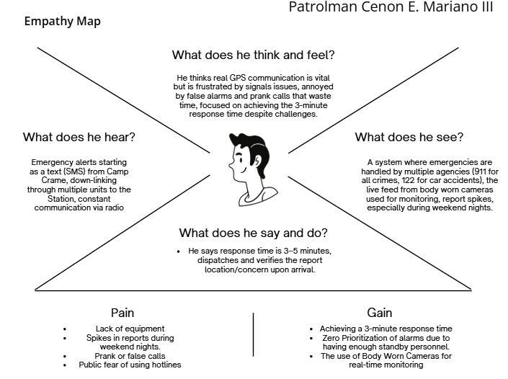

Figure 2: CFRS. Mark John B. Manalansan
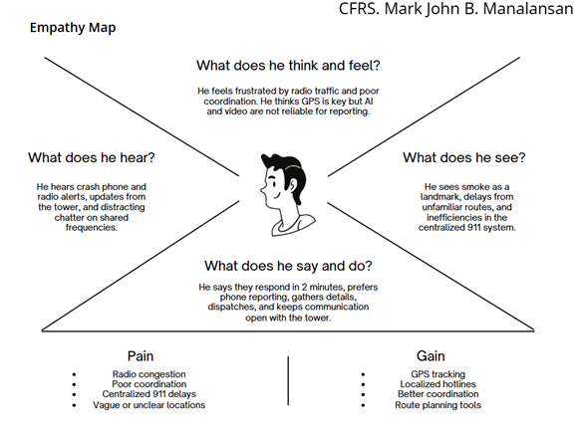

Figure 3: Dr. Daniel T. Roldan
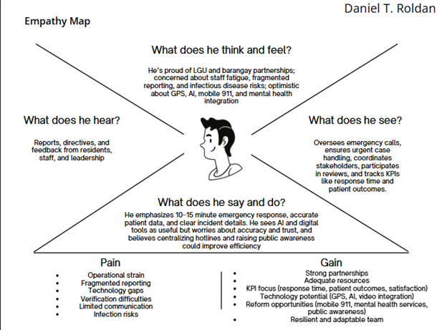

Stage 2: Define
In the Define stage, we shift from gathering insights to identifying the key challenges faced by our stakeholders. From the Empathize phase, we organized the concerns of community members and responders into clear themes.
We found recurring issues such as unclear location reporting, communication overload, and coordination gaps. These insights shaped our problem statements and “How Might We” questions, keeping our focus on the real needs of citizens and first responders.

Clustered Problems
In the Define stage, problems were grouped into key themes. Responders face delays from unclear locations, slow communication, and poor coordination. Limited tools, weak signals, and prank reports add to the challenge. These issues highlight the need for a faster and more reliable emergency reporting system.
Location and Reporting Issues
- Unclear or inaccurate emergency locations cause delays.
- Lack of precise GPS guidance for responders.
- Difficulty verifying authenticity of reports.
Communication and Coordination
- Overloaded radio traffic during emergencies.
- Poor coordination between responders and agencies.
Technology and System Limitations
- Limited equipment and outdated systems affect efficiency.
- Current systems rely too heavily on manual calls.
Human and Organizational Challenges
- False alarms or prank calls add strain on responders.
- Limited manpower during overlapping emergencies.
- Training gaps for digital and AI-powered emergency systems.

Problem Statement
Location & Reporting Issues
- Many emergency calls lack specific details, making it hard to pinpoint the exact location.
- Inaccurate or vague addresses often lead to longer response times.
- Unfamiliar routes delay responders, especially when there is no GPS guidance.
- Verification of emergencies is slow due to prank calls or incomplete reports.
- Lack of real-time location sharing prevents responders from reaching the scene quickly.
Communication Challenges
- Overloaded radio traffic causes critical messages to be missed.
- Centralized communication systems slow down responses in regional areas.
- Simultaneous calls from different users create confusion during emergencies.
- Dependence on manual calls makes reporting slower and less efficient.
Coordination Gaps
- Limited collaboration between agencies delays critical decisions.
- Information sharing is inconsistent, leading to duplicate or missed actions.
- Multiple agencies sometimes overlap roles, causing confusion.
- Lack of clear protocols slows down team coordination.
- Regional offices depend heavily on central command, delaying responses.
Technology & Resource Limitations
- Outdated equipment reduces efficiency during emergencies.
- Weak or unstable signals disrupt communication systems.
- Emergency reporting lacks integration with modern tools like mobile apps.
- Responders often rely on manual systems instead of automated alerts.
- Lack of funding prevents upgrades in essential technology and equipment.
Human & Organizational Issues
- False alarms or prank calls consume resources and slow down real emergencies.
- Limited manpower makes it hard to respond to multiple incidents at once.
- Responders experience stress due to poor processes and unclear instructions.
- Training gaps limit the adoption of new digital or AI-based tools.
- Emergency teams face burnout from handling repetitive and unverified reports.
How-Might-We
After analyzing the interviews, empathy maps, and pain-gain insights, the team categorized the identified issues into five major clusters: Location & Reporting, Communication, Coordination, Technology & Resources, and Human Factors. These clusters represent the most urgent challenges faced by both community members and emergency responders.
- How might we ensure that emergency reports provide accurate and specific location details?
- How might we use GPS to guide responders to unfamiliar routes faster?
- How might we allow users to still submit essential information (type of emergency, location) when they have no internet connection?
- How might we improve coordination between multiple agencies during emergencies?
- How might we minimize prank or false reports without discouraging genuine reporting
- How might we design the user interface so that even in panic situations, users can still operate the app effectively?
- How might we show responders why the AI classified an incident as fire, riot, or medical to build trust in the system?
- How might we ensure citizens and responders don’t miss urgent alerts, even if their phone is on silent or locked?
Conclusion
After analyzing the results of the interviews, empathy maps, and clustered problems, we identified key challenges in location reporting, communication, coordination, technology, and human factors. These insights helped us shape clear problem statements and “How Might We” questions, ensuring our focus stays on the real needs of citizens and responders. With these definitions in place, we are ready to move forward to Stage 3: Ideate, where we will begin developing possible solutions for E-ksena.

Stage 3- Ideate
In the Ideate stage, we worked as a team to brainstorm creative solutions for E-ksena. We encouraged open collaboration to reframe the problems identified earlier and set clear objectives that meet the needs of both citizens and responders. The goal is to design E-ksena as a faster, more accurate, and reliable emergency reporting system.

Brainstorming Session
Crazy 8’s
In this session, we sketched using bond papers for the Crazy 8’s to sketch ideas quickly, starting with a 1-minute rounds and then explaining to each other what our sketches meant to expand our concepts. Each of us created simple visual representations of potential solutions across the eight how-we-might's. Through this iterative approach, we were able to identify overlooked elements, investigate fresh possibilities, and expand upon each other's concepts. Subsequently, we exchanged and deliberated on the most compelling sketches, which steered us toward more creative and effective solutions.

Figure 4. Paul Brian Sumilhig (Team Leader)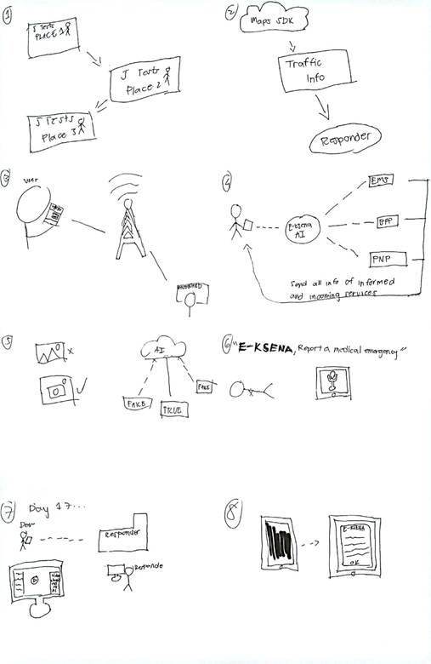

Figure 5. Jesmark Unit Tester Front end
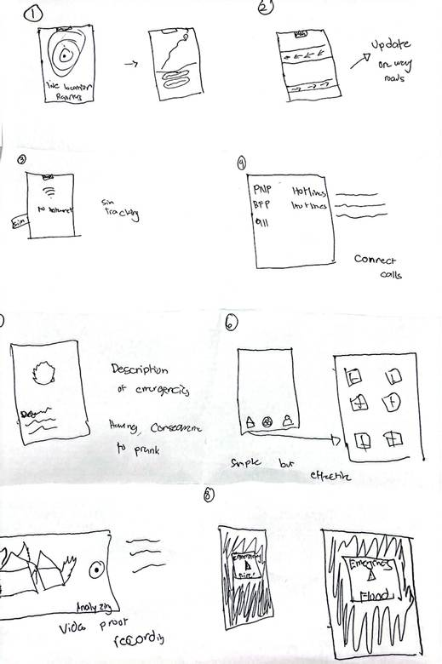

Figure 6. Peter Backend / Security
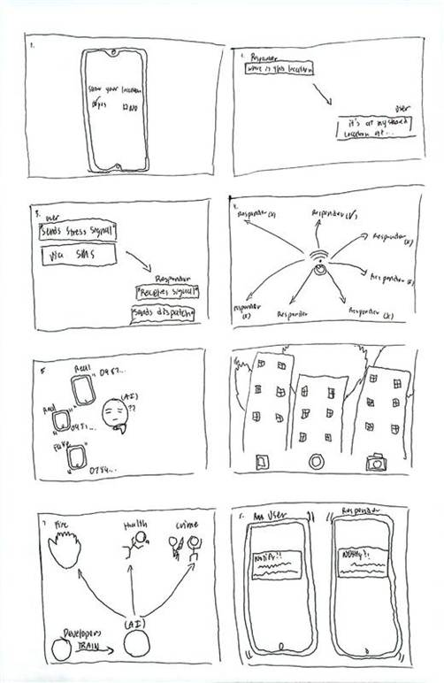

Figure 7. Lance Cloud Engineer/Front-end

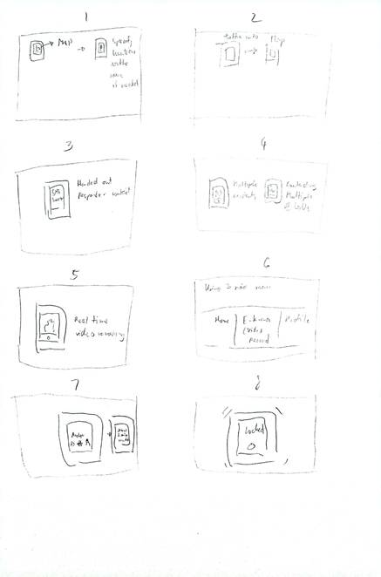

Post It Voting
Following the Crazy 8’s exercise, we compiled our concepts onto a FigJam board and conducted a vote to identify the most valuable ideas. This process enabled us to focus on the key features that would best serve the system. The chosen concepts then served as the foundation for developing prototypes and setting the stage for upcoming testing phases within the design thinking workflow.

Figure 8. Post it Voting
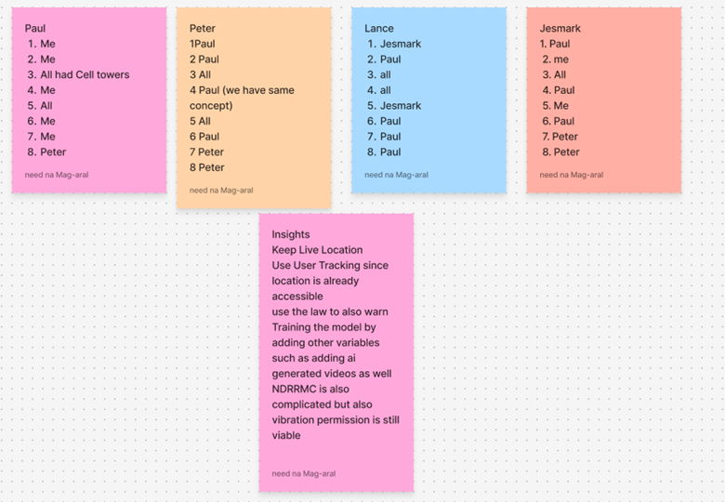

Figure 9. Desirable, Viable, Feasible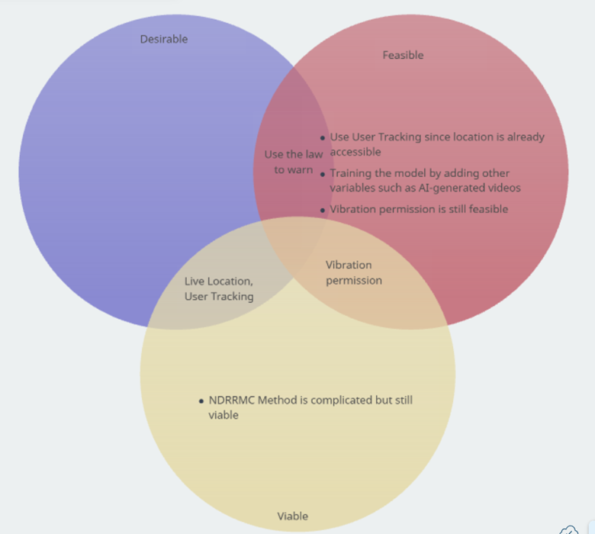
The Venn diagram organizes potential features of the E-Ksena app into Desirable, Viable, and Feasible categories. Features like keeping live location and user tracking are both desirable to users and technically feasible. The feature to use the law to issue warnings is desirable, aligns with policy, and overlaps all three areas, making it a strong candidate for implementation. Vibration permission is technically feasible and viable but not necessarily a key user-desired feature. Training the AI model with additional variables, such as AI-generated videos, is feasible but requires more development effort. This framework helps prioritize features that balance user value, practicality, and technical capability for E-Ksena’s development.

Stage 4: Prototype

4.1 Story Boards
Storyboards are visual narratives that reflect our collaborative journey with the users. This would help us understand how they will interact with our solutions.

Figure 10. Citizen Log in
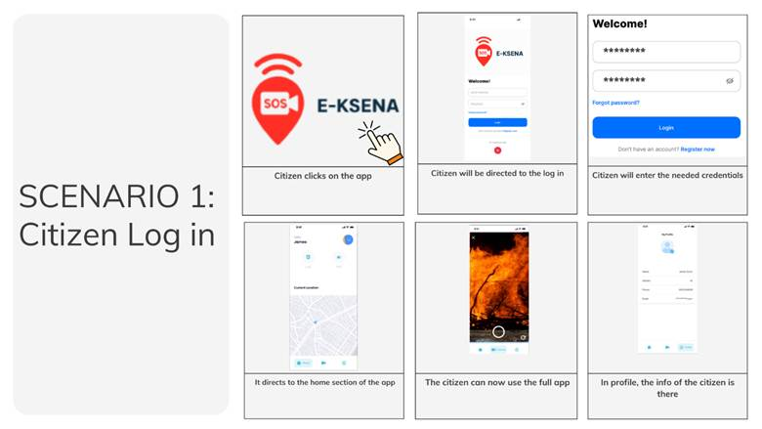

Figure 11. Citizen Report
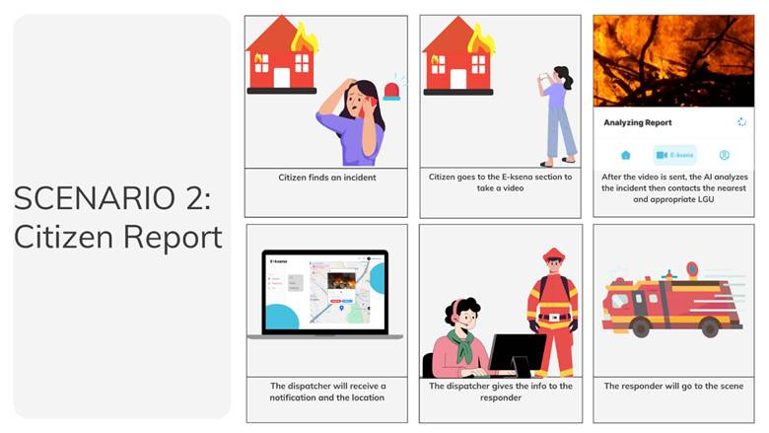

Figure 12. User Communication
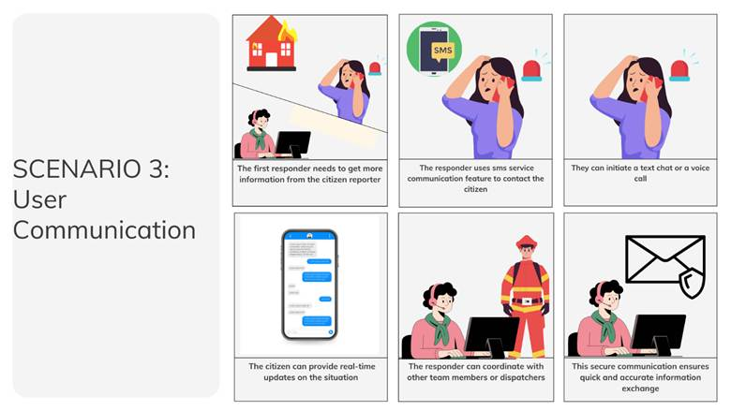

Figure 13. User Dispatcher Log in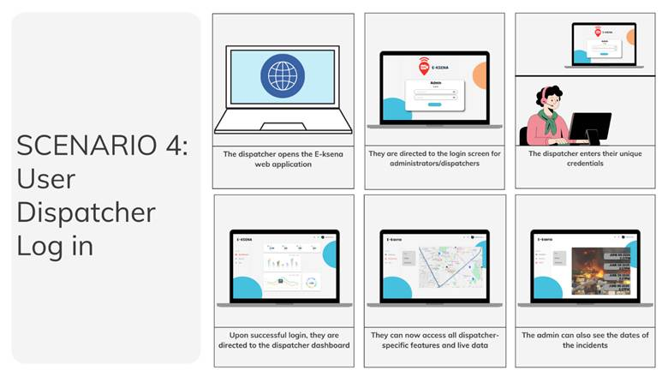

Figure 14. Dispatcher Responds
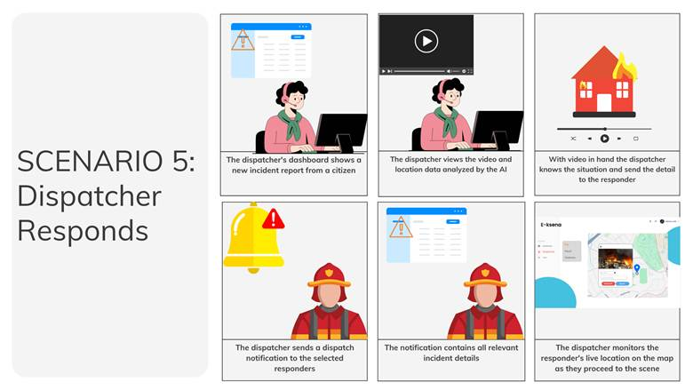

Figure 15. Report Stats
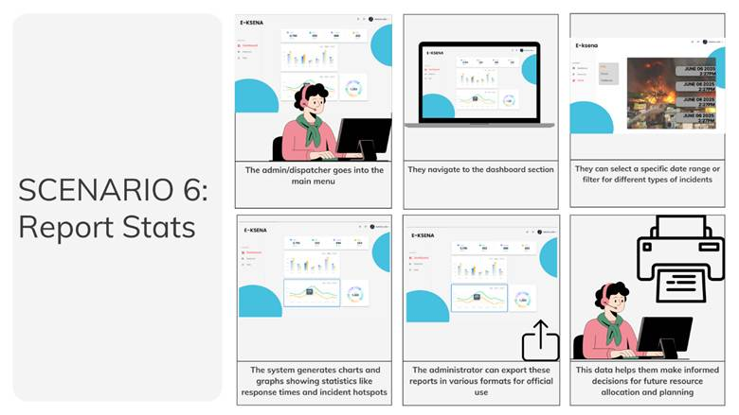

4.2 Wireframe
Wireframes are the architectural blueprints of our designs, we provide a simplified, structural representation of our solutions, focusing on layout and functionality.

Figure 16. Login Page
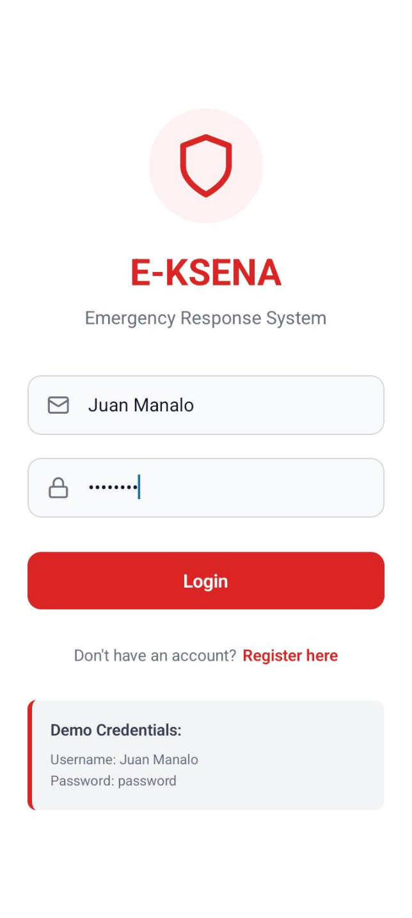
Figure 16 shows the login page of the mobile version of E-KSENA, which appears when the user opens the application. This page prompts users to enter the email address and password they used during registration. If the user has not yet registered, they are directed to the registration page. Logging in is required to access the user dashboard and to submit emergency reports.

Figure 17. Registration Page
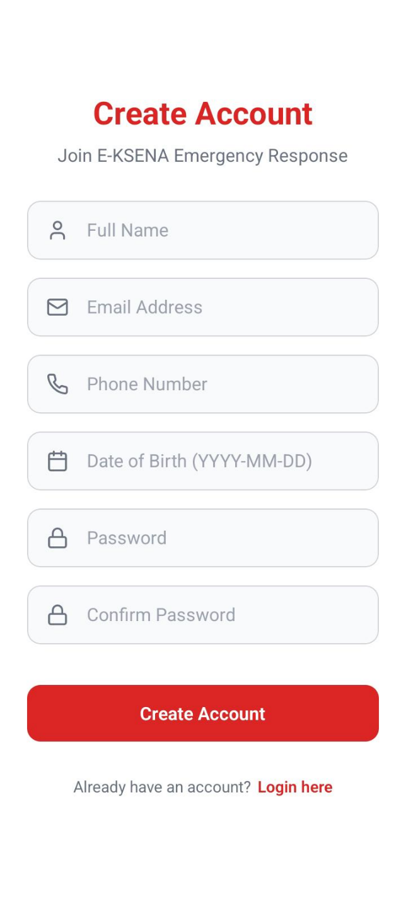
Figure 17 shows the registration page of the Mobile version of Eksena. Users must register first if they have not created an account. In this page, it will ask for your name, birthdate, email address, contact number and desire password as well as a medical condition if you have one.

Figure 18. Home page
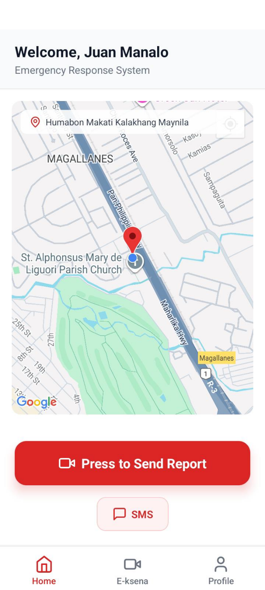
Figure 18 shows the Home page of the Mobile version of Eksena. In this page, you will see your current location, profile and

Figure 19. Recording of Incident
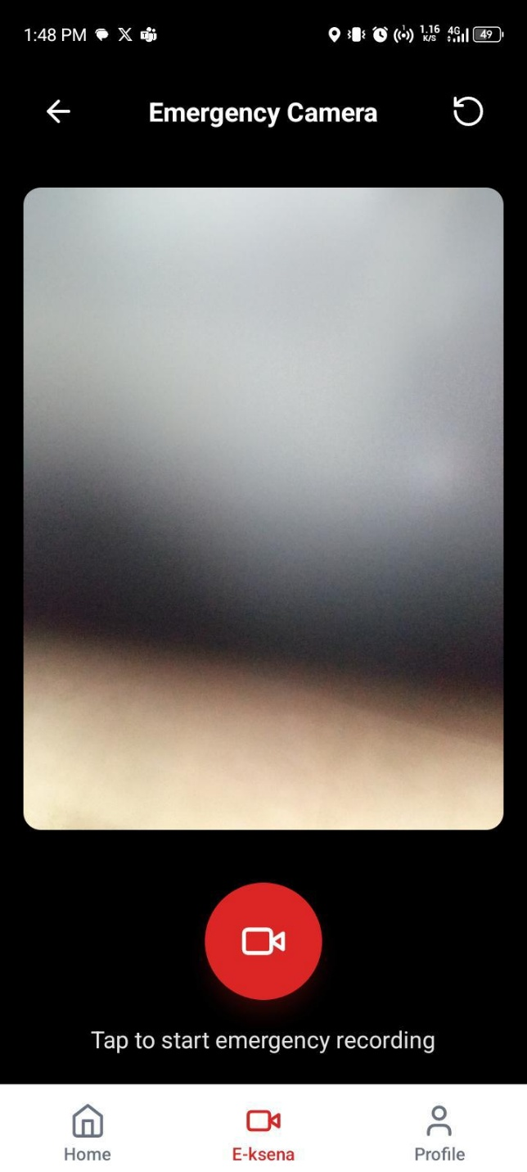
Figure 19 shows the recording page. In this page, Users will be able to record a 5 – 10 Second video of the incident.

Figure 20. Sending Video
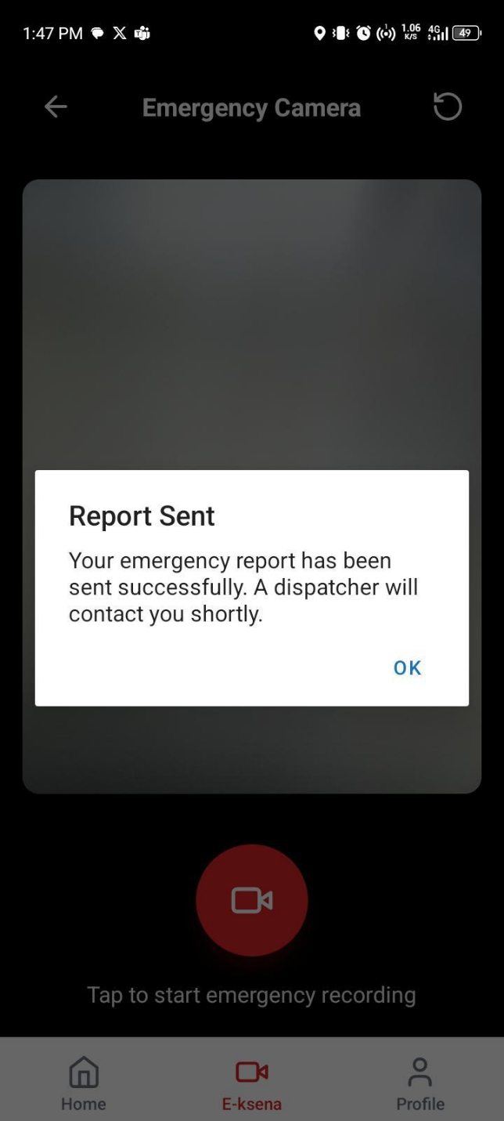
Figure 20 shows that the video of the User had taken was successfully sent to the responders

Figure 21. Website Log in
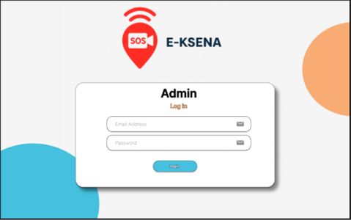
Figure 21 shows the website log in page. In this page, The only users who can access this are the responders themselves. They must log in their account to access the website.

Figure 22. Website Dashboard
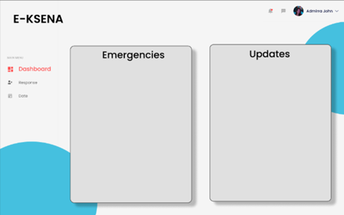
Figure 22 shows the Website dashboard that is only accessible by the responders. In this page, you’ll see the Emergencies that the Citizens have sent and the updates of these emergencies

Figure 23. Website Response Tab
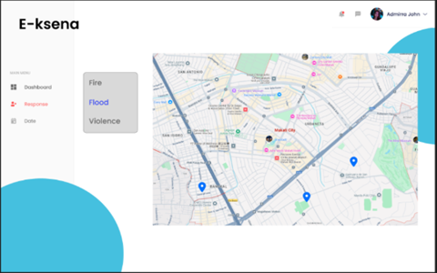
Figure 23 shows the Response Tab where all the emergencies that corollate to Flood can be found

Figure 24. Website Response Tab
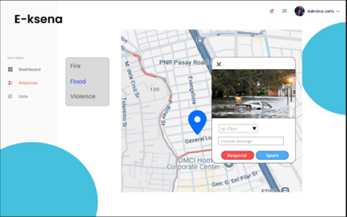
Figure 24 shows one of the areas that had sent with the video it has sent that is correlated to Floods. The responders can click respond notifying the citizen who had reported that responders have dispatches and help is on the way.

Figure 25. Website Response Tab
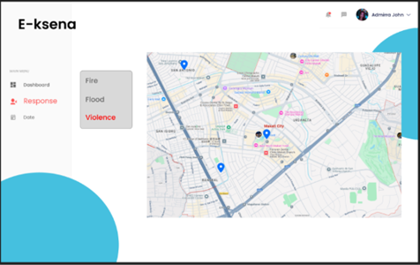
Figure 25 shows the Response Tab where all the emergencies that corollate to Violence or any accidents can be found

Figure 26. Website Incident Date Tab
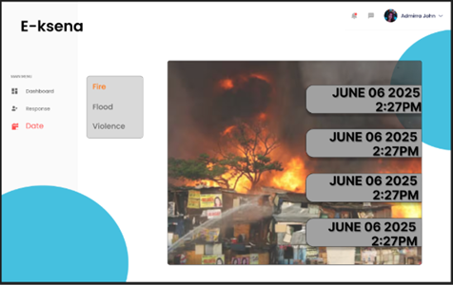
Figure 26 shows the dates of the Citizens who have sent a report of each emergency type serving as a ticket system.

Stage 5: Testing
The fifth stage of the Design Thinking process emphasizes testing prototypes to gather feedback and validate solutions. For E-Ksena, this stage has presented unique challenges, as we have not yet secured actual clients or end users to conduct formal testing sessions. As a result, all testing conducted thus far has been internal, carried out solely by our development team. While this approach has allowed us to identify certain usability issues, refine features, and simulate emergency scenarios, we acknowledge that it cannot fully replicate the perspective of real users or the diverse conditions in which the app will ultimately operate.
Despite these limitations, we have documented in our product backlogs that we are actively seeking potential clients and prospective testers. This ongoing effort reflects our commitment to incorporating authentic user feedback as soon as possible. Although it is disappointing that we have not yet been able to conduct interviews or testing with external stakeholders, these internal tests have nonetheless provided a foundational understanding of E-Ksena’s functionality and technical performance. By iteratively refining the prototype, we aim to ensure that once we secure real users, the app will be both functional and responsive to their needs.
This stage underlines the importance of preparing for real-world application, even in the absence of immediate client feedback. It allows the team to document potential pain points, validate assumptions internally, and plan structured approaches for future user engagement. Ultimately, the insights gained from our internal testing, combined with our proactive search for clients and testers, position E-Ksena for a more effective and user-centered rollout in the future.

Technology Stacks
The e-Ksena Emergency App is a robust AI-powered emergency response system that integrates multiple technological components to enable rapid reporting, classification, and coordination during crisis situations. The system has been carefully designed with both online and offline capabilities to function in a wide range of connectivity environments. Below is a breakdown of its technical foundation:
Software
- Frontend: Developed using frameworks like React Native for mobile responsiveness and intuitive design.
- Backend: Built on Node.js or Django to manage APIs, authentication, and real-time operations.
- AI Engine: Utilizes trained machine learning models (e.g., TensorFlow, PyTorch) to detect and classify emergency events from user-submitted videos.
- Database: PostgreSQL or Firebase to store user data, reports, responder status, and incident logs.
- Google Maps SDK: Supports geolocation, routing, and live map visualization for responders.
- WebRTC: Provides real-time communication via audio or video calls between users and emergency responders.

Network
- Offline Functionality:
- SMS Reporting: Allows users to report emergencies via text message when no internet is available.
- Local Caching: Enables the app to store user pins, selected map regions, and report drafts offline.
- Offline Database Mode: Incidents are saved locally and automatically uploaded once a connection is restored.
- Online Functionality:
- AI Classification: Activates machine learning models in real-time for emergency recognition.
- Google Maps SDK: Accesses live traffic data, directions, and street-level navigation.
- WebRTC: Facilitates immediate video/audio calls between users and verified emergency responders.

Peopleware
- Project Manager: Oversees scheduling, resource allocation, and coordination across roles.
- Lead Developer and Fullstack Developers: Responsible for architecting and implementing system features.
- Machine Learning Specialist: Develops and trains the emergency classification AI models.
- Quality Assurance: Conducts comprehensive testing of all app functions to ensure reliability and performance.
- LGU Liaison and Marketing Specialist: Manages coordination with emergency agencies and promotes adoption at the community level.
- Responders: The end users of the system who receive and act on incident alerts (e.g., fire, police, medics).
- Training Specialist: Provides onboarding and user education to ensure smooth deployment and usage across sectors.

Dataflow Diagrams

Figure 27. Dataflow Diagram Level 0
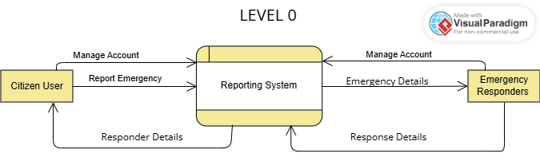

Figure 28. Dataflow Diagram Level 1
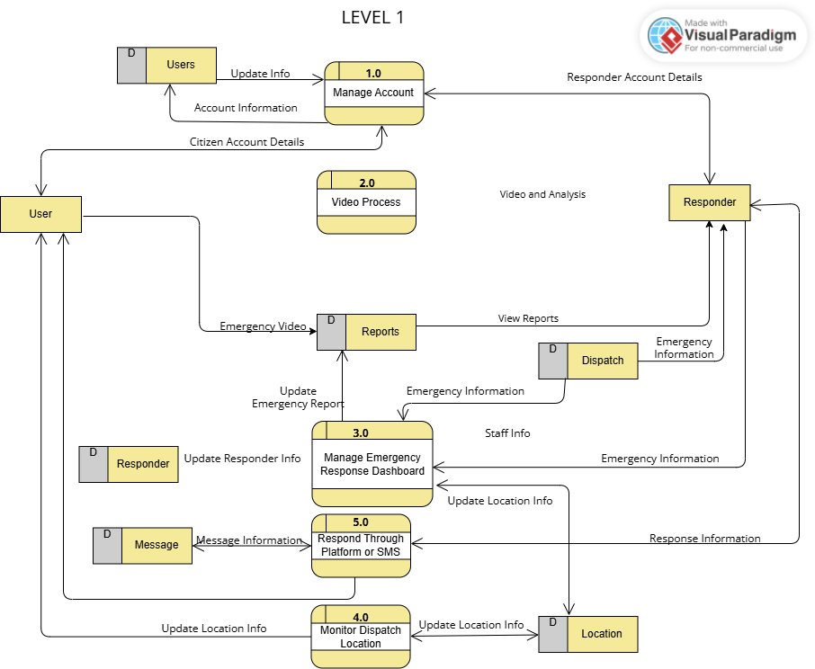

Figure 29. Dataflow Diagram Level 2.1
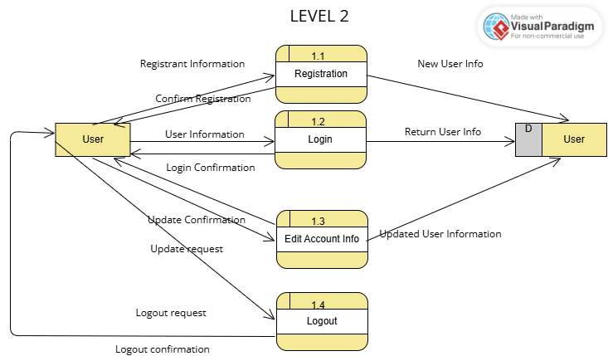

Figure 30. Dataflow Diagram Level 2.2
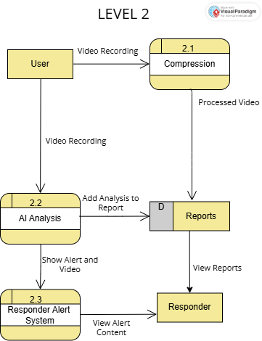

Figure 31. Dataflow Diagram Level 2.3
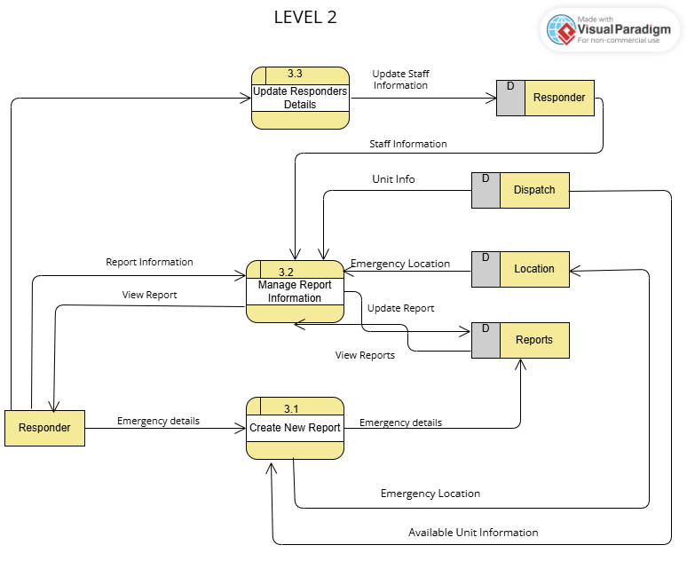

Figure 32. Dataflow Diagram Level 2.5
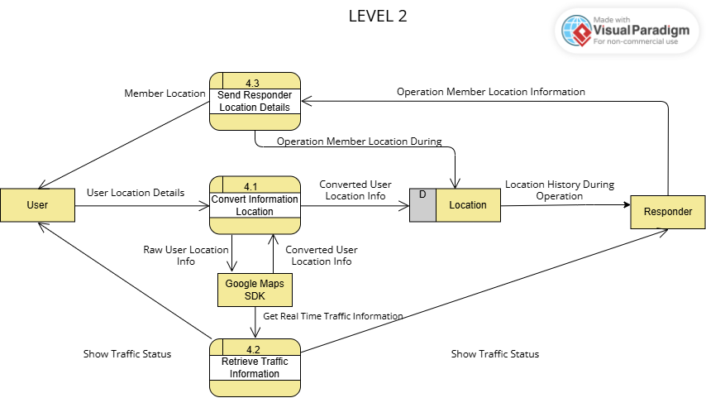

Figure 33. Dataflow Diagram Level 2.5
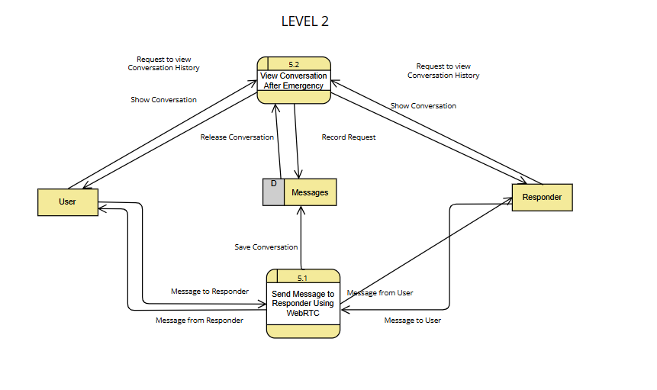

Use case Documentation

Use Case Diagram

Figure 34: Use Case Diagram
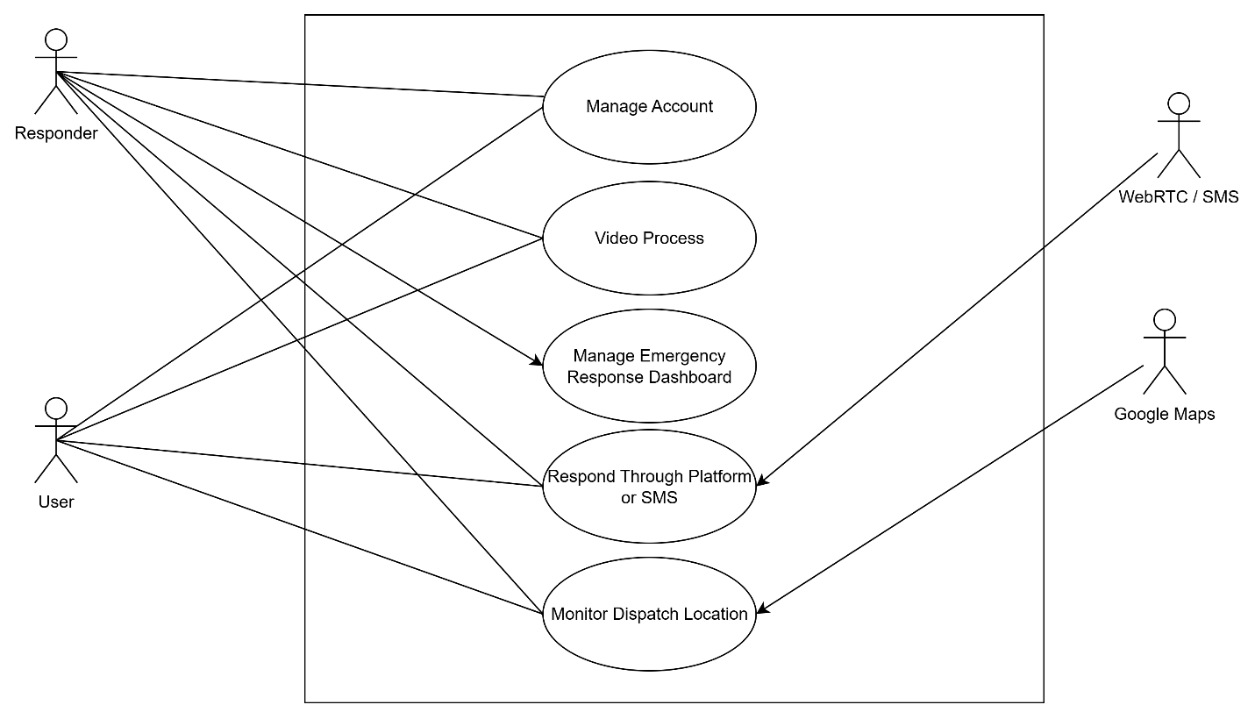
Figure 27 presents the Use Case diagram for the proposed startup application, Eksena. The diagram serves as a visual representation of the primary actors that interact with the system functionalities including user actions such as Manage Account, sending, Video Process, Emergency Response Dashboard Management, and monitoring dispatch location.

Use Case Full Description

Table 6. Use Case: User Register
Field | Value
Use Case ID | UC-01
Use Case Name | User Register
Purpose | Allow a User to create a new account with their personal and contact information.
Actors | User
Preconditions | User is not logged in.
Postconditions | New User account is created and details are stored in the system.
Requirement Traceability | BR-01
Priority | High
Flow of Actions | User opens the Registration Screen.  Enters required details.  Clicks Save.  System validates inputs and creates the account.
Alternate Flow | At step 3: If validation fails (e.g., weak password, missing field), the system displays an error and asks for correction.

Table 7. Use Case: Responder Register
Field | Value
Use Case ID | UC-02
Use Case Name | Responder Register
Purpose | Allow a Responder to create a new account with their personal and contact information.
Actors | Responder
Preconditions | Responder is not logged in.
Postconditions | New Responder account is created and details are stored in the system.
Requirement Traceability | BR-02
Priority | High
Flow of Actions | Responder opens the Registration page.  Enters required details.  Clicks Save.  System validates inputs and creates the account.
Alternate Flow | At step 3: If validation fails (e.g., weak password, missing field), the system displays an error and asks for correction.

Table 8. Use Case: User Log In
Field | Value
Use Case ID | UC-03
Use Case Name | User Log In
Purpose | Securely grant a User access to the system by initiating an active session.
Actors | User
Preconditions | Account exists.
Postconditions | Session is initiated and User is directed to the home screen.
Requirement Traceability | BR-03
Priority | High
Flow of Actions | 1. User enters credentials (username/email and password).  2. Clicks Log in.  System verifies credentials.  System starts a session and grants access.
Alternate Flow | At step 3: If credentials are incorrect, the system displays an error message.

Table 9. Use Case: Responder Log In
Field | Value
Use Case ID | UC-04
Use Case Name | Responder Log In
Purpose | Securely grant a Responder access to the system by initiating an active session.
Actors | Responder
Preconditions | Account exists.
Postconditions | Session is initiated and Responder is directed to the home screen.
Requirement Traceability | BR-04
Priority | High
Flow of Actions | Responder enters credentials (username/email and password).  Clicks Log in.  System verifies credentials.  System starts a session and grants access.
Alternate Flow | At step 3: If credentials are incorrect, the system displays an error message.

Table 10. Use Case: User Change Password
Field | Value
Use Case ID | UC-05
Use Case Name | User Change Password
Purpose | Allow a logged-in User to securely update their account password.
Actors | User
Preconditions | User is logged in.
Postconditions | Account password is updated and stored in the system.
Requirement Traceability | BR-05
Priority | High
Flow of Actions | User opens Profile Screen.  Selects Change Password.  Enters the current password and the new password.  Clicks Save.  System validates the current password and updates the new password.
Alternate Flow | At step 3: If validation fails (e.g., current password mismatch or weak new password), the system displays an error.

Table 11. Use Case: Responder Change Password
Field | Value
Use Case ID | UC-06
Use Case Name | Responder Change Password
Purpose | Allow a logged-in Responder to securely update their account password.
Actors | Responder
Preconditions | Responder is logged in.
Postconditions | Account password is updated and stored in the system.
Requirement Traceability | BR-06
Priority | High
Flow of Actions | Responder opens Account Settings.  Selects Change Password.  Enters the current password and the new password.  Clicks Save.  System validates the current password and updates the new password.
Alternate Flow | At step 3: If validation fails (e.g., current password mismatch or weak new password), the system displays an error.

Table 12. Use Case: User Log Out
Field | Value
Use Case ID | UC-07
Use Case Name | User Log Out
Purpose | Securely terminate the active User session.
Actors | User
Preconditions | User is logged in.
Postconditions | Session is closed and local tokens are cleared.
Requirement Traceability | BR-07
Priority | Medium
Flow of Actions | User clicks Log out.  System ends the session and returns to the login screen.
Alternate Flow | At step 1: If the phone is offline then it doesn’t log out and must retry again when it is online.

Table 13. Use Case: Responder Log Out
Field | Value
Use Case ID | UC-08
Use Case Name | Responder Log Out
Purpose | Securely terminate the active Responder session.
Actors | Responder
Preconditions | Responder is logged in.
Postconditions | Session is closed and local tokens are cleared.
Requirement Traceability | BR-08
Priority | Medium
Flow of Actions | Responder clicks Log out.  System ends the session and returns to the login screen.
Alternate Flow | -

Table 14. Use Case: Send Incident Video
Field | Value
Use Case ID | UC-09
Use Case Name | Send Incident Video
Purpose | Enable the User to upload a short emergency video and automatically trigger AI analysis for report classification.
Actors | User, Responder
Preconditions | Actor is logged in and has an internet connection.
Postconditions | Video report is analyzed, classified, and stored for Responder viewing.
Requirement Traceability | BR-09
Priority | High
Flow of Actions | User opens E-ksena/Video Screen.  Records or uploads a 5–10 s video.  Clicks Submit.  AI analyzes and classifies the report.  Report is sent to Responders.
Alternate Flow | At step 3: If upload fails, the system prompts retry.

Table 15. Use Case: Send Dispatch Details (Assignment)
Field | Value
Use Case ID | UC-10
Use Case Name | Send Dispatch Details (Assignment)
Purpose | To notify assigned responders of detailed dispatch information necessary for arrival and response.
Actors | Responder
Preconditions | Report exists
Postconditions | Dispatch info sent
Requirement Traceability | BR-10
Priority | High
Flow of Actions | Responder selects report.  Assigns a responder.  Adds dispatch info.  Clicks “Send”.  Responder receives data.
Alternate Flow | At step 1: Responder decides not to assign a responder immediately, or Responder cancels it becomes null.

Table 16. Use Case: Call Responder
Field | Value
Use Case ID | UC-11
Use Case Name | Call Responder
Purpose | To allow voice communication.
Actors | User, WebRTC/SMS, Responders
Preconditions | User online
Postconditions | Call initiated
Requirement Traceability | BR-11
Priority | Medium
Flow of Actions | User opens call page.  Clicks responder contact.  Call connects via WebRTC (over the net).  Call ends upon completion.
Alternate Flow | On step 1: Responder contact is temporarily unavailable (e.g., offline or busy). System displays a clear, subtle notification informing the User of the unavailability with options to retry later or send a message instead. User either retries connection later or navigates away.

Table 17. Use Case: Respond to User
Field | Value
Use Case ID | UC-12
Use Case Name | Respond to User
Purpose | To let responders communicate (send feedback or information) to the User.
Actors | Responder, User, WebRTC/SMS
Preconditions | Incident reported
Postconditions | Feedback or info sent to User
Requirement Traceability | BR-12
Priority | Medium
Flow of Actions | Responder views report.  Clicks “Respond”.  Types message.  Sends to User.
Alternate Flow | At step 2: Responder clicks “Respond”. Responder decides to cancel before sending. System discards any typed message or recorded audio and returns to report view.

Table 18. Use Case: Contact Responder via SMS
Field | Value
Use Case ID | UC-13
Use Case Name | Contact Responder via SMS
Purpose | To send SMS in offline mode.
Actors | User, WebRTC/SMS
Preconditions | No internet
Postconditions | SMS sent
Requirement Traceability | BR-13
Priority | Medium
Flow of Actions | User opens Home Screen.  Clicks on SMS button.  App sends emergency SMS.  Responder receives message.
Alternate Flow | At step 2: User clicks on responder. Device lacks permission to send SMS or SMS sending fails. System displays a clear, subtle notification explaining the issue with guidance on enabling permissions or retrying. User retries sending SMS or cancels the operation.

Table 19. Use Case: Monitor Location
Field | Value
Use Case ID | UC-14
Use Case Name | Monitor Location
Purpose | To provide real-time location tracking of dispatched responders.
Actors | User, Google Maps, Responder
Preconditions | Responder en route
Postconditions | Map updates shown
Requirement Traceability | BR-14
Priority | High
Flow of Actions | User opens Home Screen with the map.  Location fetched from the responder.  Movement shown on the map.
Alternate Flow | At step 1: If GPS data unavailable, last known location is shown. If network drops, cached map data is displayed until reconnection.

Table 20. Use Case: View Dispatch Details
Field | Value
Use Case ID | UC-15
Use Case Name | View Dispatch Details
Purpose | To see info about a specific dispatch.
Actors | User
Preconditions | Dispatch exists
Postconditions | Info displayed
Requirement Traceability | BR-15
Priority | High
Flow of Actions | Responder selects dispatch.  Details shown.
Alternate Flow | At step 1: Details fail to load due to network or server error. System displays a clear, concise error message in a card suggesting retrying or navigation options. User retries loading or returns to previous screen.

Activity diagrams with swim-lanes

Figure 35. UC-01
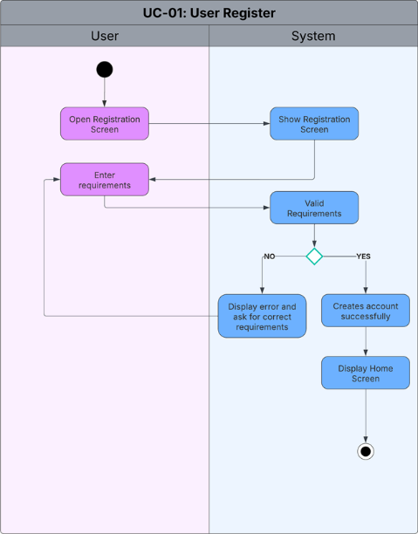

Figure 36. UC-02
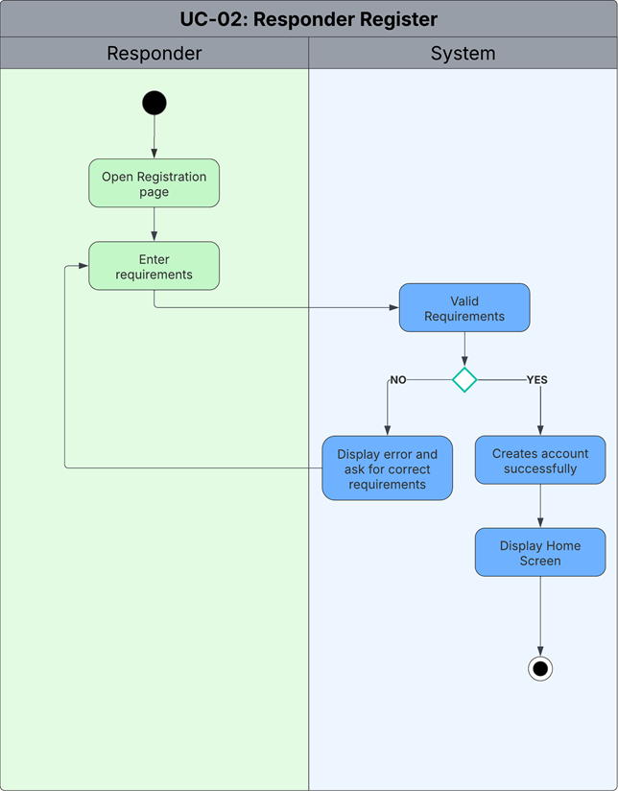

Figure 37. UC-03
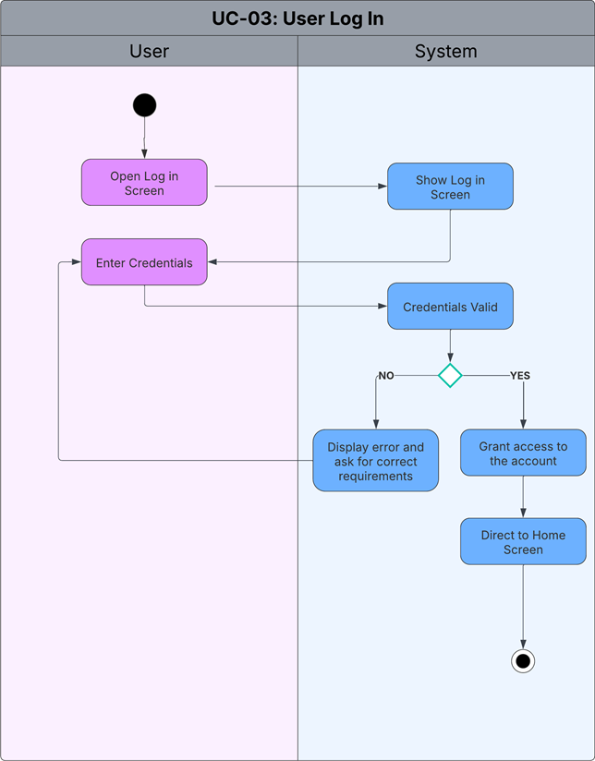

Figure 38. UC-04
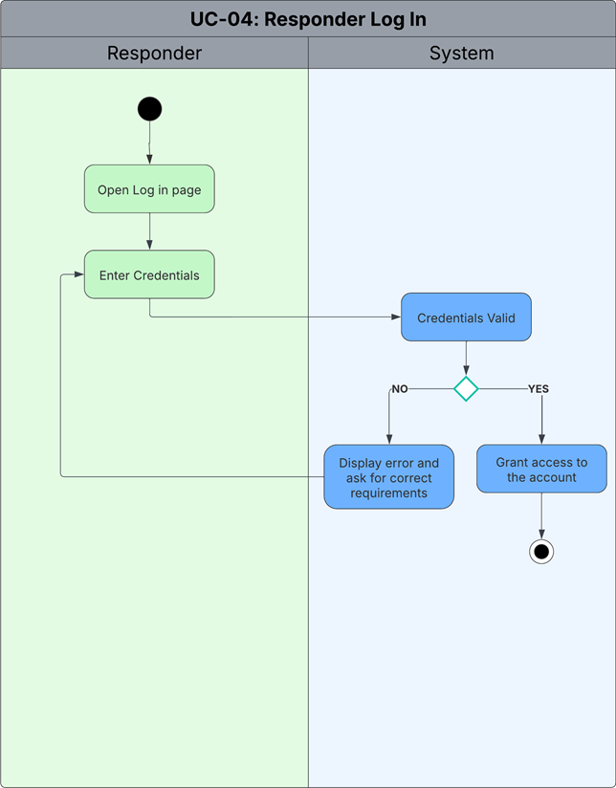

Figure 39. UC-05
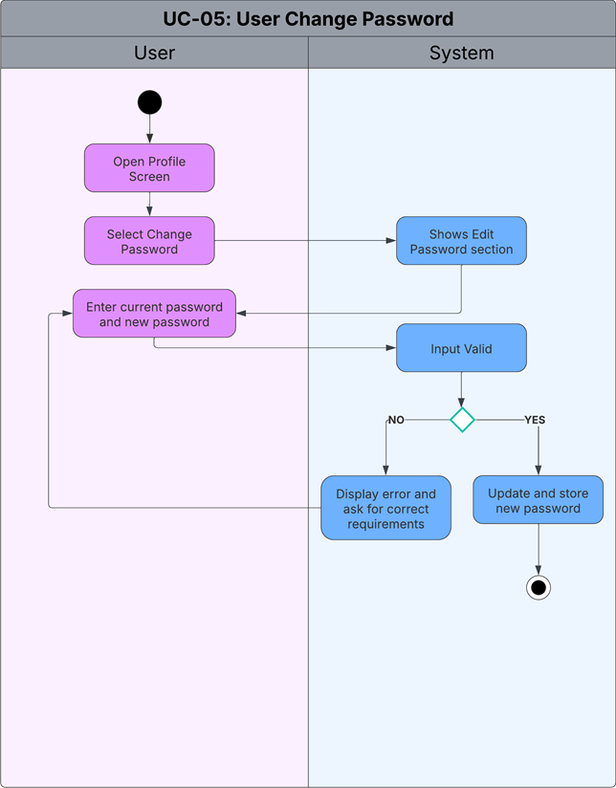

Figure 40. UC-06
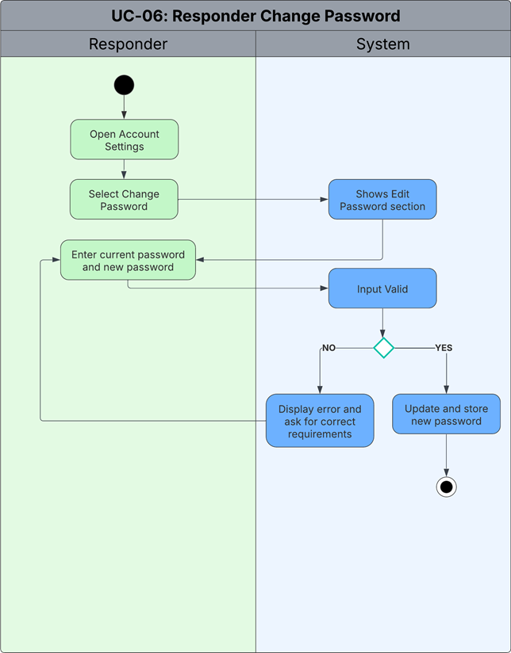

Figure 41. UC-07
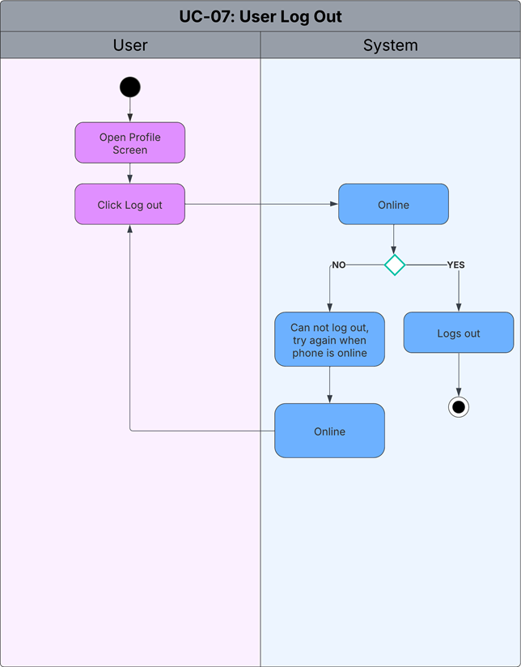

Figure 42. UC-08
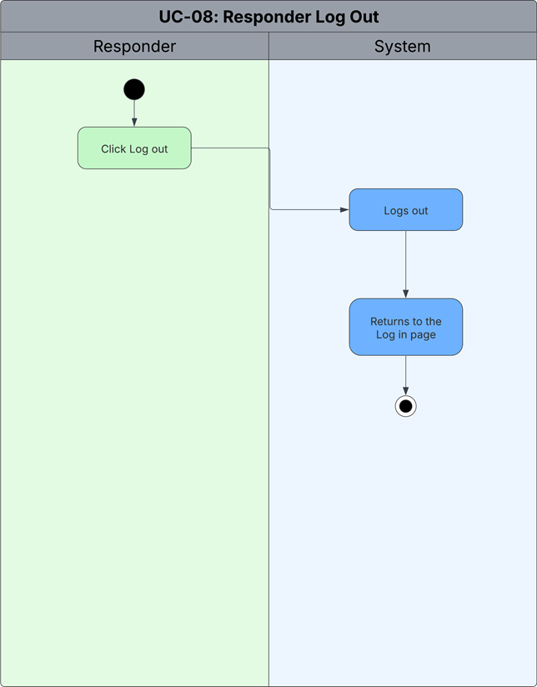

Figure 43. UC-09
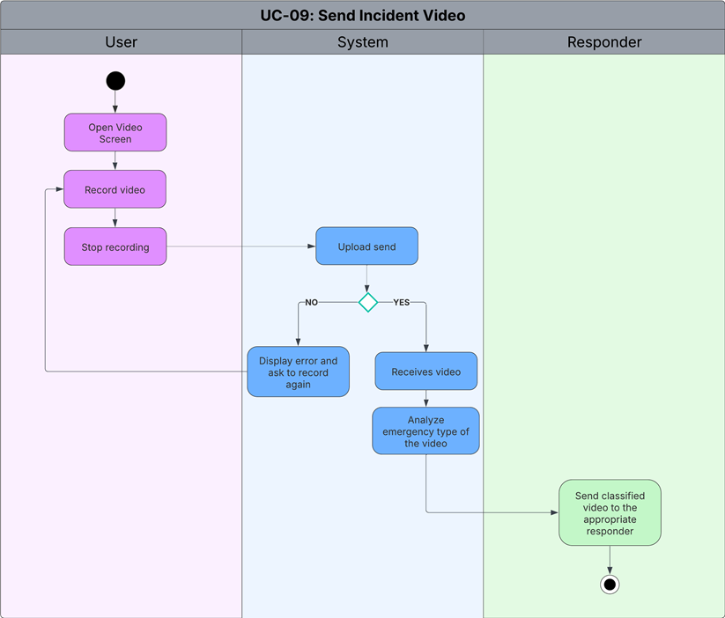

Figure 44. UC-10
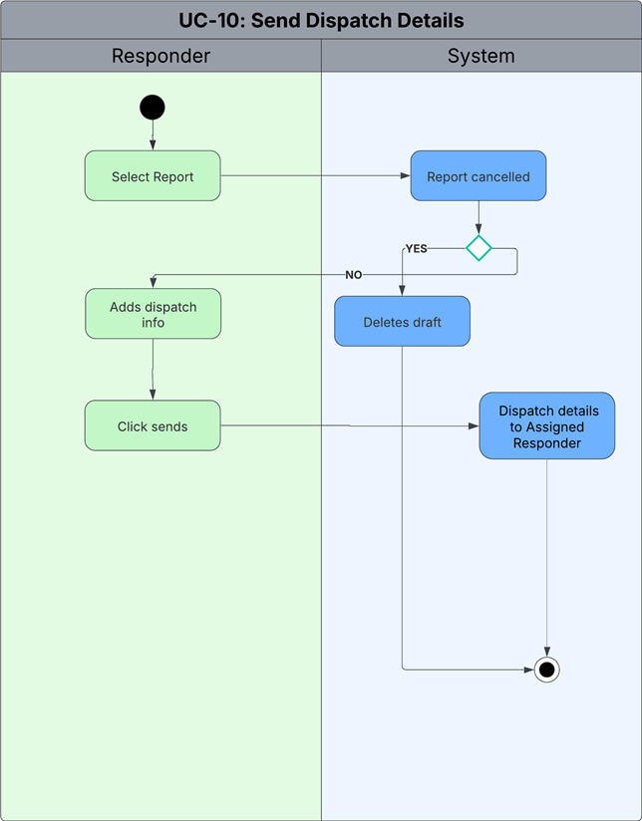

Figure 45. UC-11
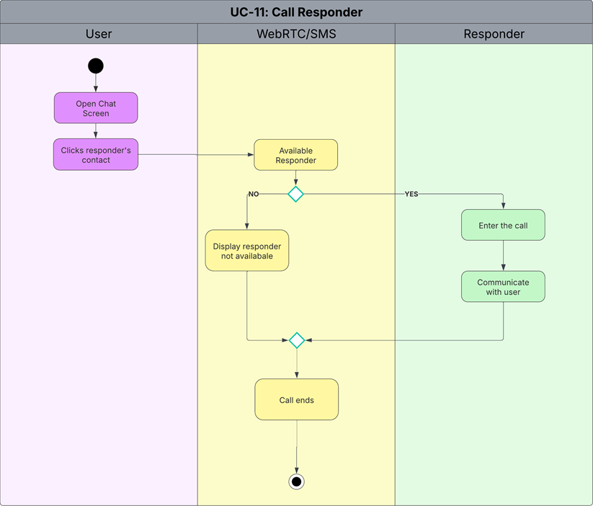

Figure 46. UC-12 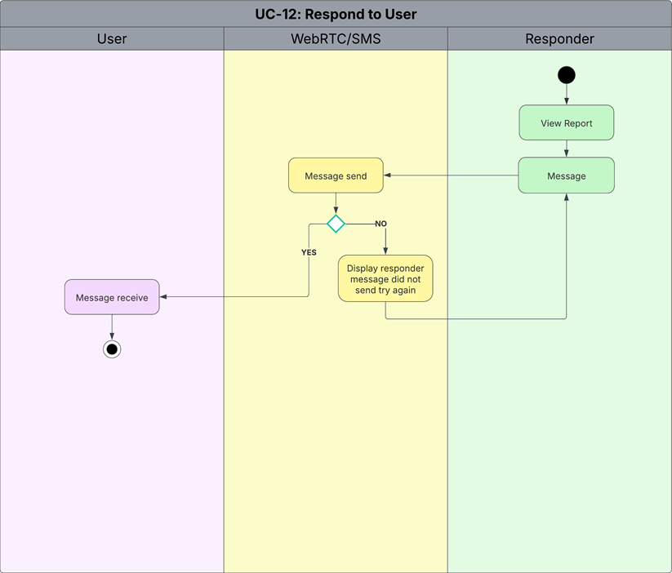

Figure 47. UC-13
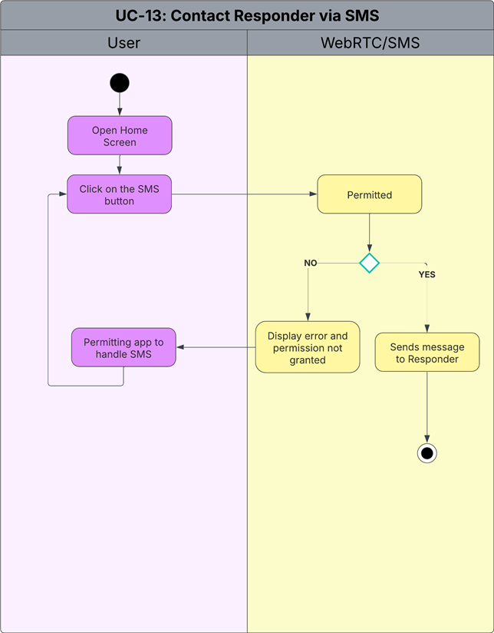

Figure 48. UC-14
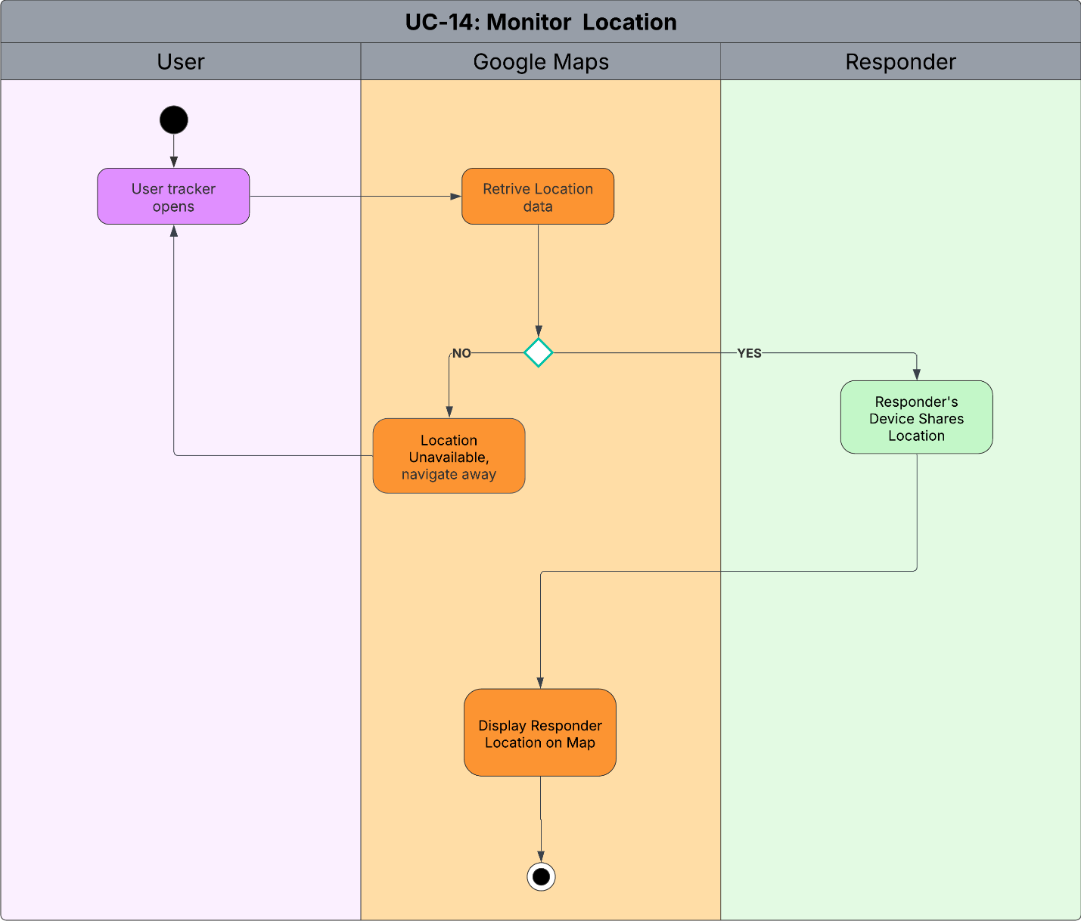

Figure 49. UC-15
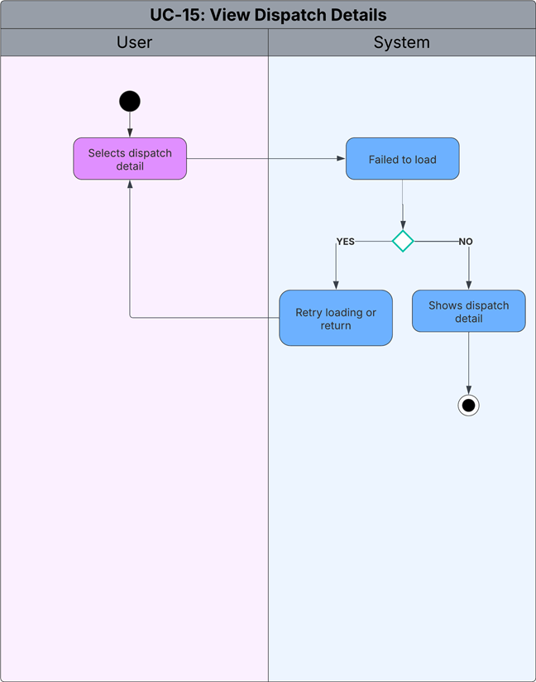

Test Cases

Table 20. Test Cases
Test Case ID | Test Steps | Input Data | Expected Results | Actual Results | Test Environment | Execution Status | Bug Severity | Bug Priority | Notes
TC-01 | 1. Open app2. Tap “Register”3. Enter valid info4. Tap “Submit” | Valid name, email, contact, password | Account successfully created; confirmation message displayed |  | Android emulator / Firebase backend | Pending | Low | High | Verify email validation
TC-02 | 1. Open app2. Enter credentials3. Tap “Login” | Registered user credentials | User logged in and redirected to home page |  | Android emulator / Web | Pending | Medium | High | Include invalid login scenario
TC-03 | 1. Open Account Settings2. Change password3. Tap “Save” | Old + new password | Password successfully updated and user notified |  | Mobile app | Pending | Low | Medium | Check weak password validation
TC-04 | 1. Tap “Report Emergency”2. Record 5–10s video3. Submit report | Emergency video (e.g., fire) | Video uploads; AI begins classification |  | Android device + AI backend | Pending | High | Critical | Core feature test
TC-05 | 1. Submit test videos (fire, medical, violence)2. Observe classification | Sample video dataset | AI correctly classifies ≥95% of test samples |  | AI model test environment | Pending | High | Critical | Accuracy validation
TC-06 | 1. Responder logs in2. Opens “Reports” tab | Received reports data | Reports display correctly with status & timestamps |  | Web dashboard | Pending | Medium | High | Check timestamp sync
TC-07 | 1. Select report2. Add dispatch info3. Click “Send” | Valid dispatch info | Dispatch details sent; citizen notified |  | Web dashboard | Pending | High | High | Ensure notification works
TC-08 | 1. Tap “Call Responder”2. Wait for connection | Valid responder contact | Call connects via WebRTC; audio/video functional |  | Mobile (Wi-Fi) | Pending | Medium | High | Test call delay handling
TC-09 | 1. Responder opens report2. Clicks “Respond”3. Sends message | Sample reply message | Message received on user device |  | Web dashboard + mobile | Pending | Low | Medium | UI confirmation check
TC-10 | 1. Go offline2. Select emergency type3. Save report | Emergency type “Fire” | Report stored locally and uploaded when online |  | Android offline mode | Pending | Medium | High | Offline storage validation
TC-11 | 1. No internet2. Tap “Send via SMS” | Responder number | SMS successfully sent |  | Android physical device | Pending | Low | Medium | Verify permission prompt
TC-12 | 1. Open “Track Dispatch”2. View location | Active dispatch ID | Map displays responder’s real-time movement |  | Mobile app + GPS | Pending | Medium | High | GPS accuracy test
TC-13 | 1. Tap “View Details” | Valid dispatch record | Details correctly shown (unit, ETA, etc.) |  | Web dashboard | Pending | Low | Medium | Test network error handling
TC-14 | 1. Tap “My Location” | Device GPS | Accurate user location displayed |  | Android emulator / Google Maps SDK | Pending | Medium | High | Verify location permissions
TC-15 | 1. Tap “View Route”2. Choose destination | User & incident coordinates | Route rendered correctly with ETA |  | Google Maps SDK | Pending | Low | Medium | Include reroute scenario
TC-16 | 1. Open “Traffic” tab | GPS & internet active | Live traffic indicators appear |  | Google Maps SDK | Pending | Low | Medium | Validate data refresh
TC-17 | 1. Submit unclear video | Mixed event video | AI flags uncertainty; requests manual check |  | AI backend | Pending | High | High | Test false positive handling
TC-18 | 1. Open Analytics Dashboard2. Filter by type/date | Stored incident data | Correct charts & analytics displayed |  | Web dashboard | Pending | Medium | Medium | Performance validation
TC-19 | 1. Submit report offline2. Reconnect internet | Offline report data | System auto-syncs pending report |  | Android offline/online | Pending | Medium | High | Sync timing check
TC-20 | 1. Tap “Logout” | Active user session | User logged out and redirected to login |  | Mobile/web | Pending | Low | Medium | Verify session token removal

Conclusion
At this stage of the E-KSENA Emergency Response System development, we have successfully accomplished several foundational objectives as outlined in our initial project framework. Specifically, we have:
Completed the Planning, Analysis, and Documentation Phase: We identified the key challenges in the current emergency response systems, defined system objectives, and outlined the essential user roles including citizens and emergency responders.
Established Core Functionalities and AI Capabilities: Through concept validation and collaborative planning, we finalized the system’s key features—AI-based emergency classification, GPS-triggered geolocation sharing, and real-time mobile-to-web communication.
Developed Detailed Use Case Tables: Each core use case now includes structured fields such as preconditions, postconditions, priorities, and flow of actions (basic and alternative), providing a strong development foundation.
Outlined Data Privacy, Security, and Connectivity Strategies: Encryption standards, SMS fallback systems, and data privacy protocols have been incorporated to ensure operational resilience, compliance with Philippine laws, and accessibility in low-connectivity areas.
Selected the Technology Stack: Tools and frameworks for mobile, backend, communication, AI, and mapping have been finalized, aligning with system goals and performance requirements.
Currently, we are moving into the Design Phase, using tools such as Figma to create high-fidelity wireframes for both the citizen-facing mobile app and the responder web dashboard. This includes interfaces for video reporting, alert monitoring, emergency classification, and responder notifications. Continuous engagement with pilot communities and emergency units (e.g., BFP, PNP) is being conducted to ensure practical relevance and iterative improvement.
For the upcoming sprint, we plan to:
Finalize and validate UI/UX wireframes for all modules
Begin system prototyping and integrate core frontend-backend interactions
Implement initial AI model testing for video classification
Set up the development and testing environments using the approved tech stack
Conduct a technical review and begin development sprints focused on MVP completion
By adhering to our planned timeline and agile development cycle, we aim to deliver a reliable, AI-powered emergency app that directly supports national public safety goals and aligns with the Sustainable Development Goals (SDG) and NIASD through digital transformation, inclusivity, and timely crisis response.

References
[1] Rappler.com, "Every minute counts: The tech behind PH's upgraded 911 emergency response system," Mar. 5, 2025. [Online]. Available: https://www.rappler.com/technology/features/next-generation-advanced-911-capabilities-philippine-deployment/
[2] Inquirer.net, "Police respond to 78% of 911 calls within five minutes – PNP," Jan. 14, 2025. [Online]. Available: https://newsinfo.inquirer.net/2024568/police-respond-to-78-of-911-calls-within-five-minutes-pnp
[3] M. A. Alqahtani and A. A. Mohammed, "An Optimization-based Approach Model for the Improvement of the Performance of Emergency Medical Service Ambulances," in Proc. Int. Conf. Ind. Eng. Oper. Manage. (IEOM), 2019. [Online]. Available: http://www.ieomsociety.org/ieom2019/papers/293.pdf
[4] E. R. Villa and J. M. Garcia, "Factors Affecting the Response Times of Emergency Response Vehicles Deployed in Selected Barangays in Quezon City," ResearchGate, Dec. 23, 2023. [Online]. Available: https://www.researchgate.net/publication/333163344_Factors_Affecting_the_Response_Times_of_Emergency_Response_Vehicles_Deployed_in_Selected_Barangays_in_Quezon_City
[5] D. B. Costa et al., "AI-based approach for transcribing and classifying unstructured emergency call data: A methodological proposal," PLOS Digital Health, vol. 2, no. 12, Dec. 2023. [Online]. Available: https://www.researchgate.net/publication/376265718
[6] K. Wang, K. Jimmerson, and W. Yang, "EmergEye: AI-Based Car Accident Detection and Notification System," UC Berkeley School of Information, 2024. [Online]. Available: https://www.ischool.berkeley.edu/projects/2024/emergeye-ai-based-car-accident-detection-and-notification-system
[7] Y. Zeng et al., "Emergency Vehicle Sound Detection Using Extreme Learning Machines," Sensors, vol. 25, no. 3, p. 793, Jan. 2025. [Online]. Available: https://www.mdpi.com/1424-8220/25/3/793
[8] E. Linder et al., "Emergency Classification Using LLMs to Support Public Safety Telecommunicators," arXiv preprint, arXiv:2402.10908, Feb. 2024. [Online]. Available: https://arxiv.org/abs/2402.10908
[9] Huang and Gao, “Location-Based services,” Mar. 2018. https://www.researchgate.net/publication/324748144_Location-Based_Services
[10] S. S. Rawat, “The tech behind Google Maps: How AI, real-time data power its navigation,” @bsindia, Feb. 14, 2025. https://www.business-standard.com/technology/tech-news/the-tech-behind-google-maps-how-ai-real-time-data-power-its-navigation-nc-125021401068_1.html
[11] T. J. McCue, “Life360 GPS Tracker Can Help You Keep Family Members Safe,” Forbes. https://www.forbes.com/sites/tjmccue/2021/12/31/life360-gps-tracker-can-help-you-keep-family-members-safe/

Milestone | Estimated Week
Finalization of UI/UX wireframes and user flow | Week 6
Development of core features (Platform, Cloud Systems, Ais, Google Maps Integration) begins | Week 7 - 9
Responder dashboard setup and system integration | Week 12
Internal testing (team only) | Week 10 (3 Days)
Usability testing with at least 50 users | Week 10 - 11
Gathering feedback and making revisions
Final testing and polishing | Week 12 - 13
Project presentation and final defense preparation | Week 14

Appendices

Appendix A: Roles and Responsibilities

Table 21. Roles and Responsibilities
Team Member | Role | Responsibilities
Paul Brian Sumilhig | Project Manager | Lead project execution and coordination  Manage timeline, scope, and budget  Align stakeholders and team goals
 | Lead Developer | Define technical system architecture  Supervise development and integrations  Resolve complex coding issues
 | Machine Learning Specialist | Train emergency detection models  Optimize AI accuracy and speed  Manage datasets and evaluations
Peter Arquines Jr. | Documentation Lead | Write technical documentation  Maintain user guides  Support onboarding materials
 | Quality Assurance Lead | Design test strategies  Supervise testing team  Ensure bug-free functionality
 | Fullstack Developer | Develop across frontend/backend  Integrate full system features  Troubleshoot platform issues
Lance Benedict Onnagan | LGU Liaison | Coordinate with local governments  Align emergency response protocols  Gather stakeholder feedback
 | Marketing and Communications Specialist | Manage public outreach campaigns  Promote app adoption  Create user materials
 | Fullstack Developer | Develop across frontend/backend  Integrate full system features  Troubleshoot platform issues
Jesmark David Presbitero | Release Manager | Oversee deployment schedules  Manage version control  Ensure stable releases
 | Fullstack Developer | Develop features that involve both frontend and backend technologies  Support overall platform development with technical flexibility  Assist in troubleshooting cross-layer issues
 | Training Specialist | Train users and responders  Develop learning materials
 | QA Tester | Run test cases  Report bugs and issues  Validate app performance
Table __ outlines the current roles and responsibilities of each team member. Since we are still in the early stages and have not yet entered the development phase, the roles—especially those related to coding, testing, and deployment—are subject to change as the project progresses.

Appendix B: Minutes of the Meetings

Minutes of the Meeting
Date: May 28, 2025
Time: 3:30 PM
Location: Asia Pacific College
Attendees:
Lance Benedict Onnagan
Peter Jr Arquines
Jesmark Presbitero
Agenda:
Discussion and Updates of the project
Next steps and action items
Key Points Discussed:
Introduction:
Brief overview of the meeting purpose and agenda.
Main Discussion Topics:
Key insights and decisions made.
Important updates and feedback.
Challenges faced and proposed solutions.
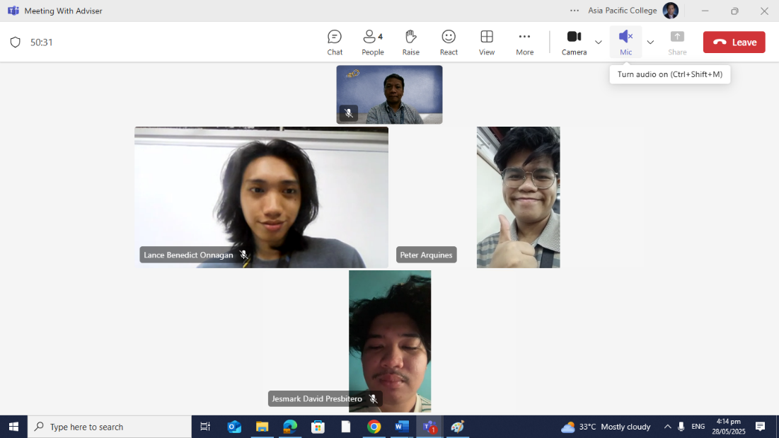

Date: June 04, 2025
Time: 3:30 PM
Location: Asia Pacific College
Attendees:
Paul Brian Sumil
Peter Jr Arquines
Jesmark Presbitero
Agenda:
Discussion and Updates of the project
Next steps and action items
Key Points Discussed:
Introduction:
Brief overview of the meeting purpose and agenda.
Main Discussion Topics:
Key insights and decisions made.
Updates to data gathering in
Challenges faced and proposed solutions.
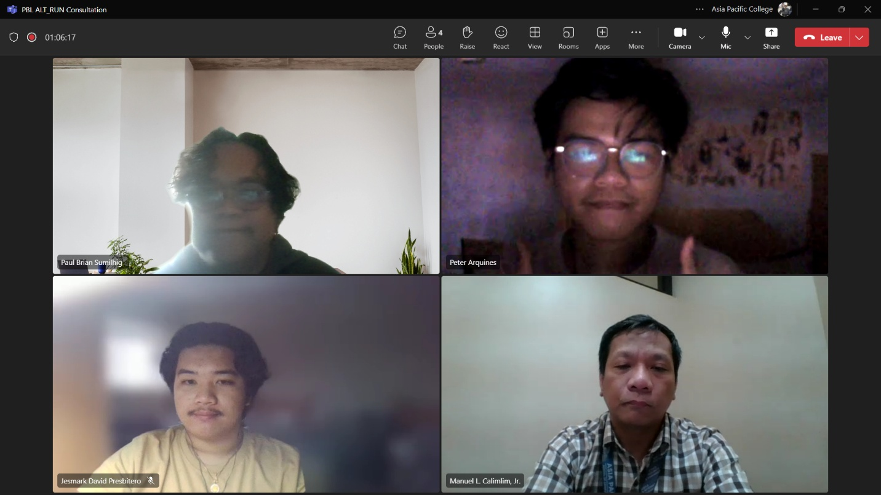

Appendix C: Methodology
1. Planning Phase
The proposed system, E-KSENA, was conceived as an innovative two-part emergency response solution consisting of:
- A mobile application enabling citizens to report emergencies via short 5–10 second videos.
- A web-based dashboard for real-time incident monitoring, classification, and response by first responders.
- The core vision centers on leveraging AI, geolocation, and real-time communication to enhance response speed, accuracy, and accessibility, particularly for citizens unable to express emergencies verbally.
- Key planning goals included:
- Reducing emergency reporting time to under 60 seconds
- Designing for use with low or no data connectivity
- Enabling inclusive access across language and literacy barriers
- 2. Analysis and Documentation Phase
An extensive requirements analysis was conducted based on stakeholder consultations, existing emergency communication gaps, and benchmarking against local and global best practices.
Creative Vision Principles:
- Empowering Citizens to become digital first informants through effortless video reporting.
- AI-Driven Analysis to replace traditional hotline calls with visual classification.
- Inclusive Design for users regardless of language proficiency or connectivity.
- First-Responder Enablement through real-time location-aware reporting systems.
- Identified Functional Requirements:
- Video capture, classification, and submission
- Real-time web dashboard with incident visualization
- Emergency type selection (online/offline)
Voice/video communication fallback systems
Secure data handling and encryption
Non-functional requirements such as scalability, reliability, and data privacy were also documented.
3. Design Phase
The technical design and architecture includes the following components:
- AI Video Classification using CNNs and 3D CNNs trained on emergency footage datasets and deployed via TensorFlow Lite or TensorFlow Serving.
- Video Capture and Compression using H.264 codecs to ensure fast, low-bandwidth uploads.
- Geolocation and Mapping via Google Maps SDK, enabling real-time responder tracking and emergency mapping.
- Mobile-Web Real-Time Communication implemented through Firebase Realtime Database/Firestore.
- Multi-modal Communication Systems including WebRTC/Agora.io and SMS fallbacks (Globe Labs, Smart DevNet).
- Data Privacy and Security architecture adhering to the Philippine Data Privacy Act (RA 10173) with AES-256 encryption and HTTPS transmission.
4. Development Phase
Development was split into frontend and backend efforts:
- Mobile App built using Flutter or React Native for cross-platform support.
- Web Dashboard designed using responsive web frameworks integrated with Firebase services.
- AI Models trained using TensorFlow and PyTorch with emergency video datasets.
- Backend Services implemented with Node.js and Firebase Functions.
- Security enforced via OAuth2, secure data storage, and access controls.

5. Testing and Quality Assurance
The following testing protocols were implemented:
- Unit Testing of individual modules (e.g., AI classifier, video compression).
- Integration Testing for mobile-to-dashboard communication.
- User Acceptance Testing (UAT) with selected emergency personnel and citizens in target locations.
- Security Testing to verify encryption, authentication, and access policies.
- Edge Case and Offline Scenarios testing to simulate low-connectivity usage.
- Mitigation strategies were put in place for:
- AI misclassifications (human override systems)
- Connectivity dropouts (video queuing and SMS fallback)
- Spam/fraud reports (rate limiting, user tracking)
6. Deployment and Handover
Initial pilot deployment is planned in high-traffic urban zones like Makati and Quezon City. Activities include:
- Onboarding local emergency units (PNP, BFP, hospitals)
- Controlled field testing with simulated incidents
- Training sessions for responders using the dashboard
- Collection of pilot feedback for iterative improvements
7. Maintenance and Feedback
Post-launch, e-KSENA will enter the maintenance phase, which includes:
- Bug Fixes and Hotpatches based on real-time user feedback
- Regular Model Retraining of AI classifiers to improve accuracy
- Support Channels for both citizens and responder agencies
- Analytics Dashboard to monitor usage and detect incident trends
- Planned Future Enhancements:
- Multi-language Support (Tagalog, Cebuano, etc.)
- Campus Mode for school-specific alerts
- Pattern Recognition & Prediction using historical data
- Nationwide Integration with agencies like MMDA and NDRRMC

Appendix D: Project Sharepoint Link
ALT_RUN FINALS

Appendix E: Requirements Traceability Matrix

Table 22. Requirements Traceability Matrix
REQUIREMENT ID | REQUIREMENT DESCRIPTION | USE CASE ID | TEST CASE ID
BR-01 | User can Register | UC-01 | TC-01
BR-02 | Responder can Register | UC-02 | TC-02
BR-03 | User can Log In | UC-03 | TC-03
BR-04 | Responder can Log In | UC-04 | TC-04
BR-05 | User can Change Password | UC-05 | TC-05
BR-06 | Responder can Change Password | UC-06 | TC-06
BR-07 | User can Log Out | UC-07 | TC-07
BR-08 | Responder can Log Out | UC-08 | TC-08
BR-09 | Users can send a video reporting an incident | UC-09 | TC-09
BR-10 | Responder can send dispatch detail (Assignment) | UC-10 | TC-10
BR-11 | User can call Responder | UC-11 | TC-11
BR-12 | User can respond to User | UC-12 | TC-12
BR-13 | User can contact responder through text if offline | UC-13 | TC-13
BR-14 | User can monitor dispatch location | UC-14 | TC-14
BR-15 | User/Responder can view Dispatch Details | UC-15 | TC-15

Appendix F: Entity Relationship Diagram

Figure 50. Entity Relationship Diagram
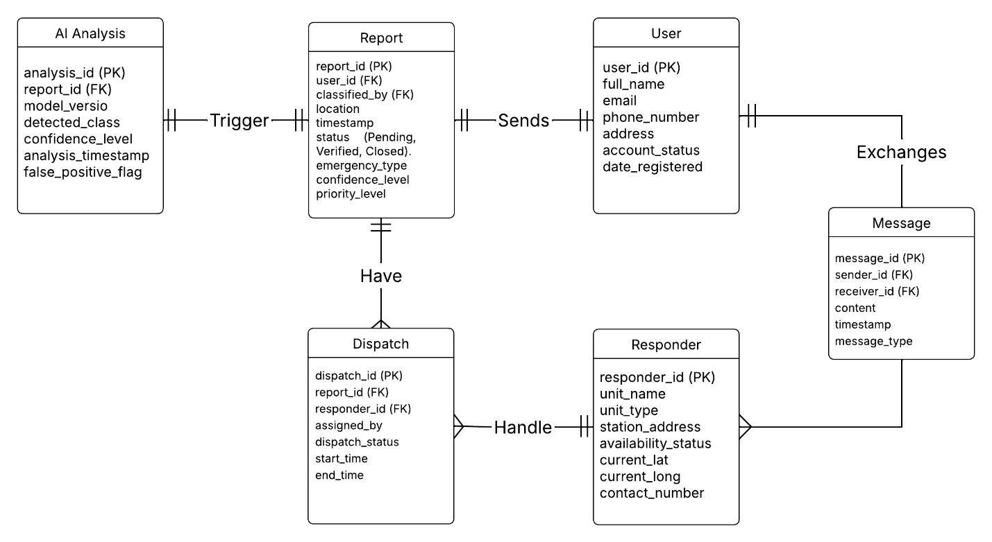

Appendix G: Openproject Activities
Budgets
Budgets | APC_2025_2026_T1_SS231_G06 ALT_RUN Eksena | OpenProject
Roadmap
Roadmap | APC_2025_2026_T1_SS231_G06 ALT_RUN Eksena | OpenProject
Work Packages
Work packages | Work Packages | APC_2025_2026_T1_SS231_G06 ALT_RUN Eksena | OpenProject
Backlogs
Backlogs | APC_2025_2026_T1_SS231_G06 ALT_RUN Eksena | OpenProject
AY 2025-2026 T1 Sprint 01 Board
ALT_RUN 2025-2026 T1 Sprint | Boards | APC_2025_2026_T1_SS231_G06 ALT_RUN Eksena | OpenProject
Gantt Chart
Gantt charts | APC_2025_2026_T1_SS231_G06 ALT_RUN Eksena | OpenProject

